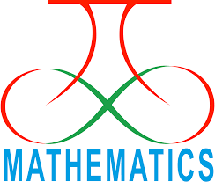
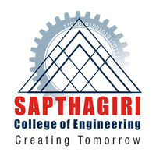
SAPTHAGIRI COLLEGE OF ENGINEERING
(Affiliated to Visvesvaraya Technological University, Belgaum)
#14/5 Chikkasandra, Hesaraghatta Main Road, Bengaluru-560057

DEPARTMENT OF MATHEMATICS

MATHEmatica
AY 2017-2018

VISION  To be a model for excellence in undergraduate education in Mathematics | MISSION  To provide every undergraduate student with mathematical experiences and mathematical ideas that will serve as a foundation for career and further study in engineering mathematics and science

Chairman: Sri.G Dayanand | Executive Director:Sri G.D Manoj
The “MATHEmatica”  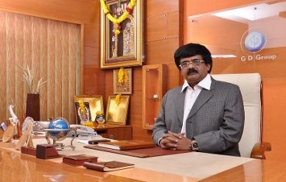  ”newsletter of the department Mathematics is providing great space for the faculty and students to pen down their innovative ideas, imagination and perceptions to show case their creativity. So, I take the opportunity to congratulate the department of Mathematics and its editorial team to successful release of this issue. I am sure that students and faculty will find the content of this edition very interesting and educating. | 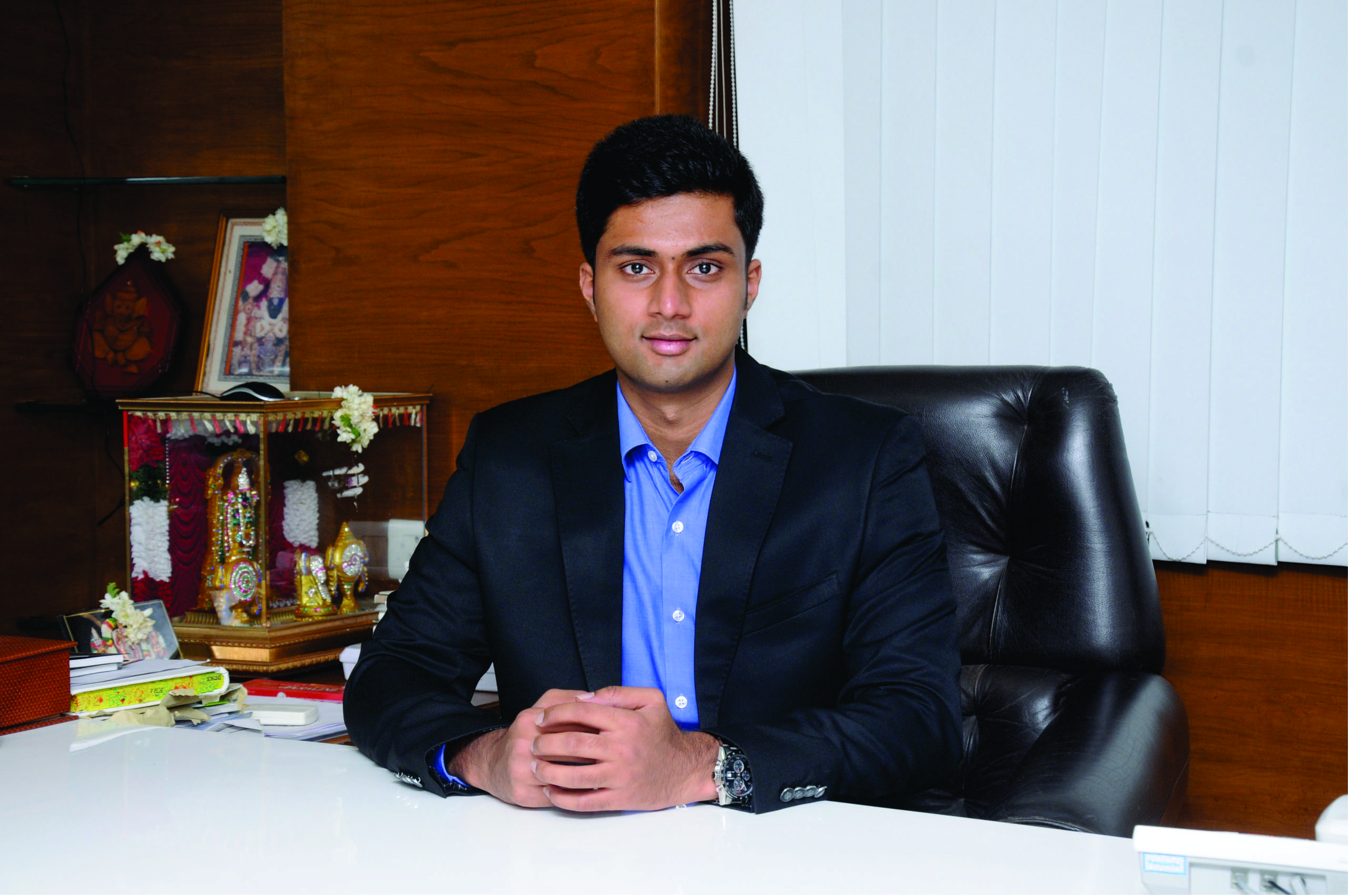  I am indeed happy to know that the department of Mathematics has taken initiative in realizing its monthly newsletter “MATHEmatica”” and urge faculties and students to make use of the platform to share and educate among themselves in publishing article pertaining to the emerging domain and articles of interesting. I congratulate the team of editorial community and department of Mathematics
Principal Desk | Administrator Desk
It is indeed very happy to bring out newsletter “MATHEmatica” by the department of  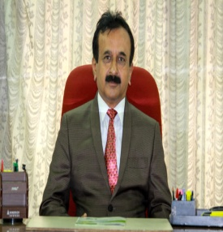  Mathematics. It is a platform provided by the department of Mathematics for their students and faculty members where they can share the knowledge, experience and talents in terms of written articles and I would like to compliment and congratulate the department of Mathematics and its editorial team for the contribution in bringing out the newsletter. | 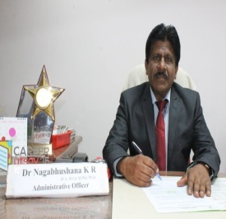  It gives me immense pleasure to note that Mathematics Department bringing out Newsletter for the academic year 2017-18. I am sure this newsletter provides an opportunity to the student’s and the faculty of the department to project their talents through articles, reports of the various academic and extracurricular programmes. I congratulate the editorial committee of the newsletter for their efforts.

HOD DESK | INSIDE THE ISSUE
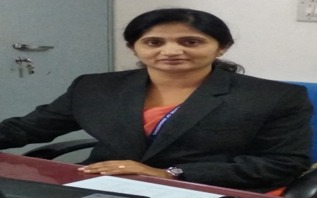  I am very happy to bring out the first issue of the Departmental Magazine “MATHEmatica”. This magazine outlines various activities took place during the academic year 2017-18 and the achievements of faculty and students. It is great to find a considerable number of articles, poems and art that certainly prove that our staff and students are adequately equipped and possess necessary skill sets to express their talent. Sincerely congratulate the Chairman, Principal, and editorial team of the department for their unrelenting efforts in compiling this Magazine. | - Vision Mission  - H.O.D’s Desk  - List of papers and publications  - Department Activities
Invited Talks and Guest Lectures
One Day Guest Lecture on was conducted on “ROLE OF MATHEMATICS IN ENGINEERING” for First Semester Students on 27 Feb 2018 by
Dr. M. SANKAR Professor, Department of Mathematics, School of Engineering, Presidency University.
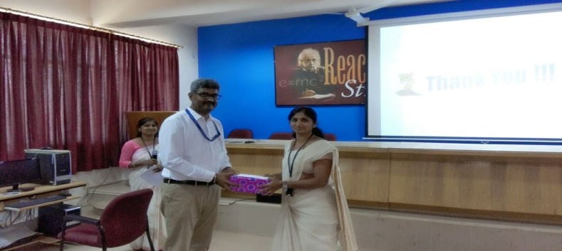

Paper Published in International/National Journals

- Dr.Pushpa B V published a paper entitled “Numerical study of double-diffusive convection in a vertical annular enclosure with a baffle” in the
Journal of Physics: Conference Series, 908 (2017) IOP Science.

Workshops/seminars attended by faculty

- Dr.Pushpa B V attended one day Faculty Development Program on “Vedic Science and education” at PES university, Bengaluru on 26/07/2018.
- Dr.Pushpa B V attended three days Faculty Development Program on “Teacher Empowerment” at Sapthagiri College of Engineering during 23rd to 25th July 2018.
- Dr.Pushpa B V attended one day workshop on “Role of Ratings, Rankings and Accreditation in Creating Institutions of Eminence and excellence” at PES University, Bangalore on 21/07/2018 organized by BITES (Board for IT Education standards).
- Dr.Pushpa B V attended one day workshop on “New Model Curriculum for First Year CBCS Detailed syllabus (2018-19) as per OBE format” at BIT, Bangalore on 8/5/2018 organized by VTU, Belagavi.

