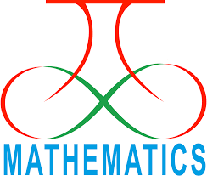
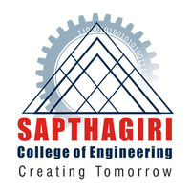
SAPTHAGIRI COLLEGE OF ENGINEERING
(Affiliated to Visvesvaraya Technological University, Belgaum)
#14/5 Chikkasandra, Hesaraghatta Main Road, Bengaluru-560057

DEPARTMENT OF MATHEMATICS

MATHEmatica

YEAR 2019-20

VISION  To be a model for excellence in undergraduate education in Mathematics | MISSION  To provide every undergraduate student with mathematical experiences and mathematical ideas that will serve as a foundation for career and further study in engineering mathematics and science

Chairman: Sri.G Dayanand | Executive Director:Sri G.D Manoj
The “MATHEmatica”  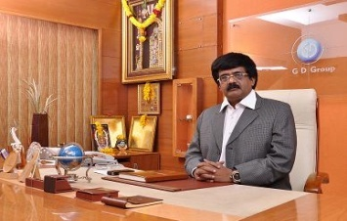  ”newsletter of the department Mathematics is providing great space for the faculty and students to pen down their innovative ideas, imagination and perceptions to show case their creativity. So, I take the opportunity to congratulate the department of Mathematics and its editorial team to successful release of this issue. I am sure that students and faculty will find the content of this edition very interesting and educating. | 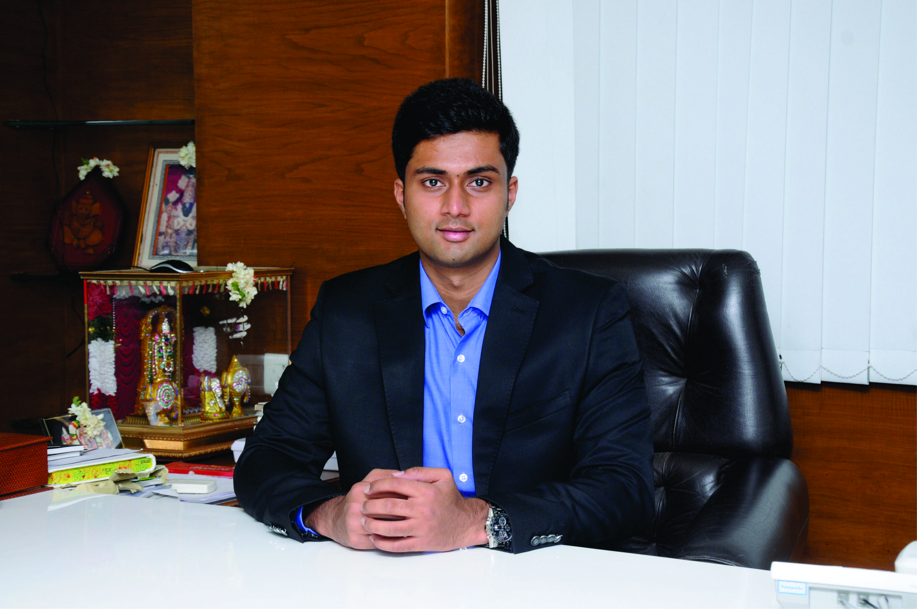  I am indeed happy to know that the department of Mathematics has taken initiative in realizing its monthly newsletter “MATHEmatica”” and urge faculties and students to make use of the platform to share and educate among themselves in publishing article pertaining to the emerging domain and articles of interesting. I congratulate the team of editorial community and department of Mathematics
Principal Desk | Administrator Desk
Dr. H Ramakrishna Principal  It is indeed very happy to bring out newsletter “MATHEmatica” by the department of  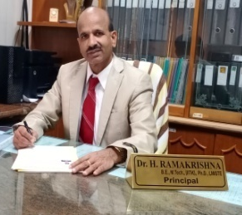  Mathematics .It gives me immense pleasure to note that, SCE has been publishing bi-annual newsletter and I am sure, this will provide an opportunity for the faculty and students to share their knowledge and beacon the information about various issues and activities that are being taking place in the department. I look forward for more activities and achievements for the department to march towards excellence in the future. I would like to thank all teaching, supporting staff and our beloved students for their active participation in publishing this magazine. My special compliments and congratulation to the editorial team of the department for their consistent effort in publishing this newsletter | Dr M H Annaiah Vice-Principal  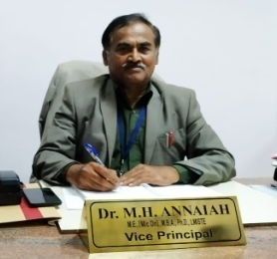  It gives me immense pleasure to note that Mathematics Department bringing out Newsletter for the academic year 2019-20. I am very happy and delighted to know that our college is bringing out the college newsletter. SCE is one of the leading premier engineering colleges in the country offering quality technical education to students thereby enabling them to become globally acceptable engineers in their domains. The newsletter provides a platform for both faculty and students to showcase their achievements and hidden talents. I congratulate our beloved principal and members of editorial board for bringing out this excellent and informative newsletter on time.

HOD DESK | INSIDE THE ISSUE
Dr.Shripad Markande HOD  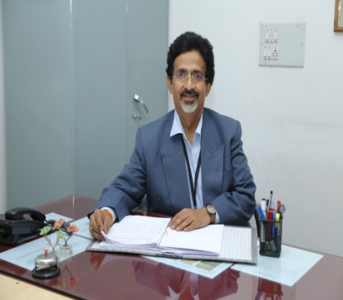  I am very happy to bring out the first issue of the Departmental Magazine “MATHEmatica”. This magazine outlines various activities took place during the academic year 2019-20 and the achievements of faculty and students. It is great to find a considerable number of articles, poems and art that certainly prove that our staff and students are adequately equipped and possess necessary skill sets to express their talent. Sincerely congratulate the Chairman, Principal, and editorial team of the department for their unrelenting efforts in compiling this Magazine. | - Vision Mission  - H.O.D’s Desk  - Department Activities
Invited Talks and Guest Lectures

Students’ Club called as “MATHEmatica” was inagrauated on 16th November 2019 .On this occasion Dr.Shripad Markande HOD Mathematics talked about “Mathematical Modelling of Simple Physical Situations” using Differential Equations .

