VTU CONSORTIUM LICENSE COPY (e-RESOURCES SUBSCRIBED)
2019-2020
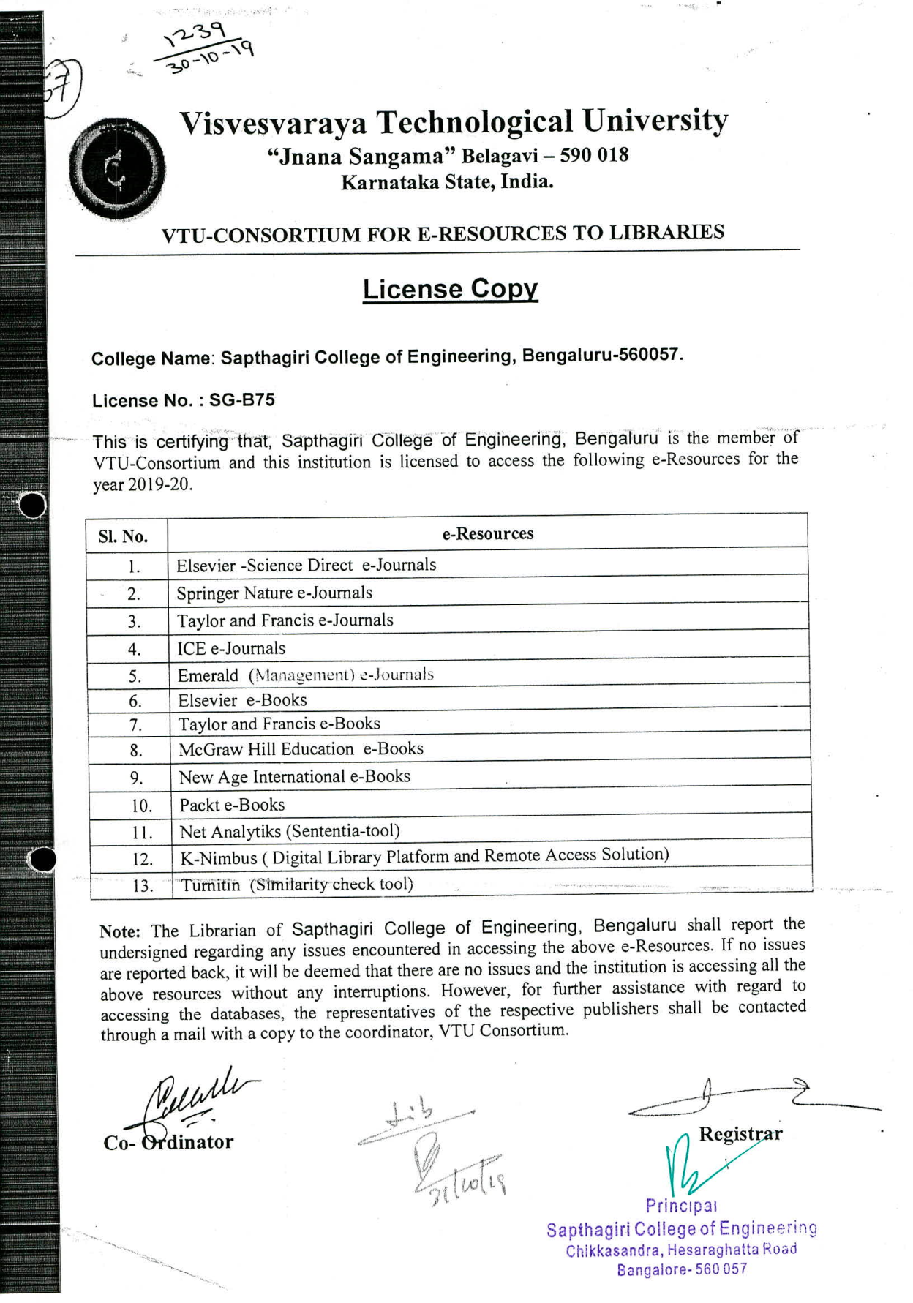
VTU CONSORTIUM LICENSE COPY (e-RESOURCES SUBSCRIBED)
2018-2019

