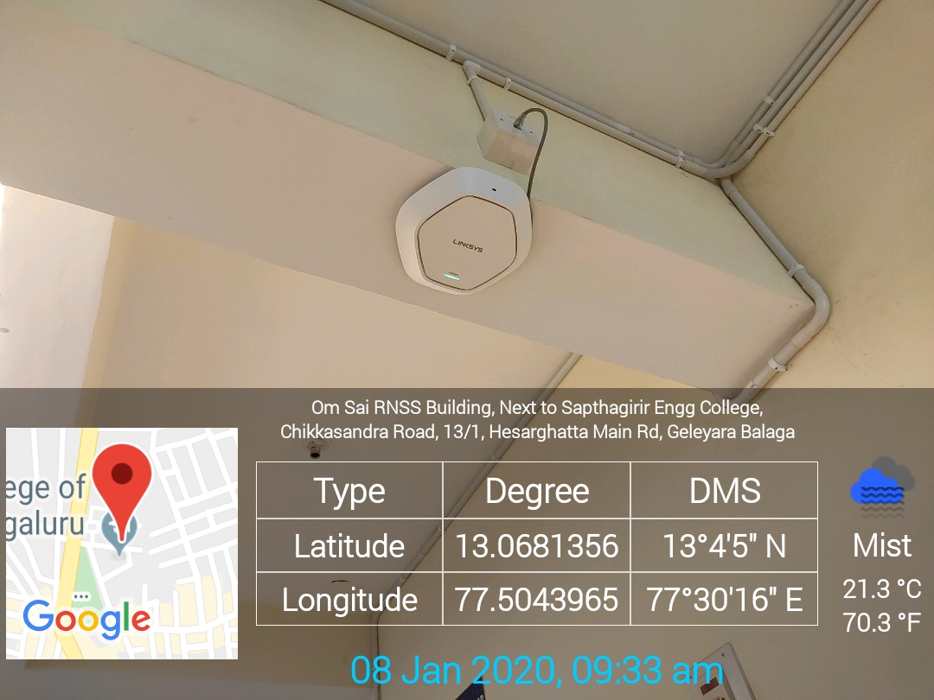
Academic Block - EEE Department – 4th Floor
WIFI (1)
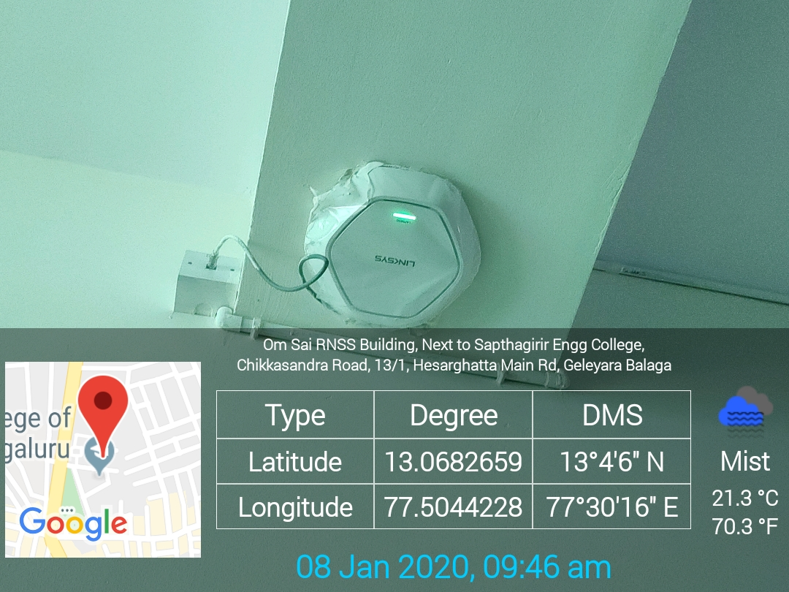
Academic Block - 4th Floor WIFI (2)
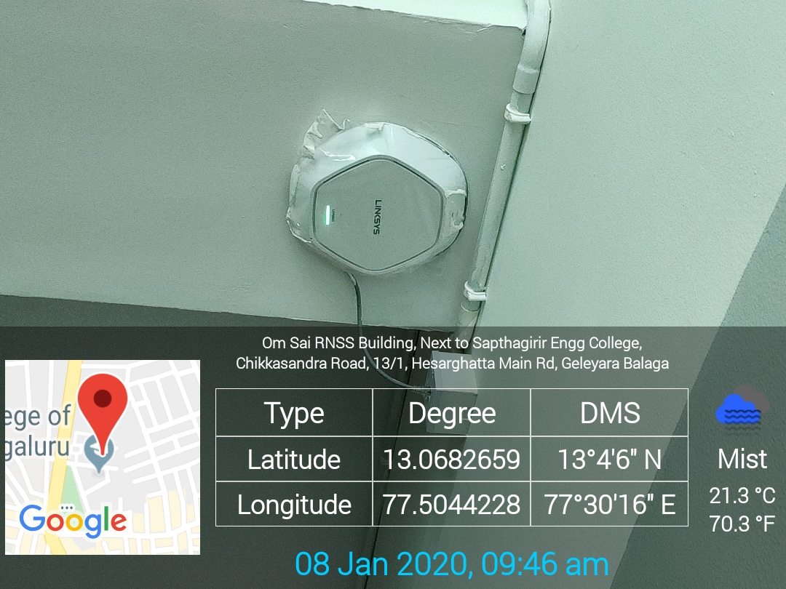
Academic Block - 4th Floor WIFI (3)

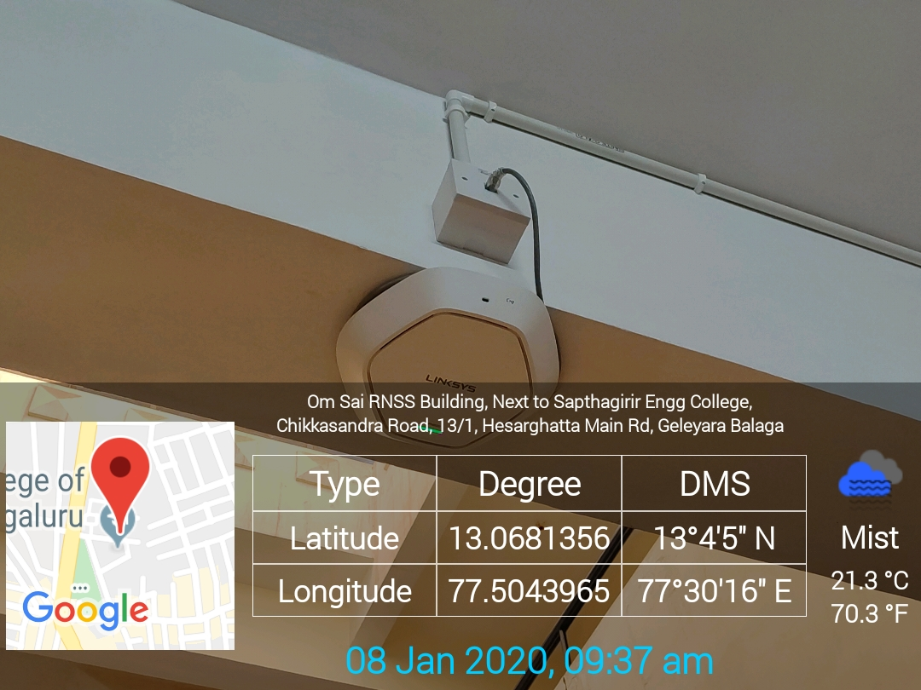
Academic Block - ISE Department – 3rd Floor
WIFI (4)

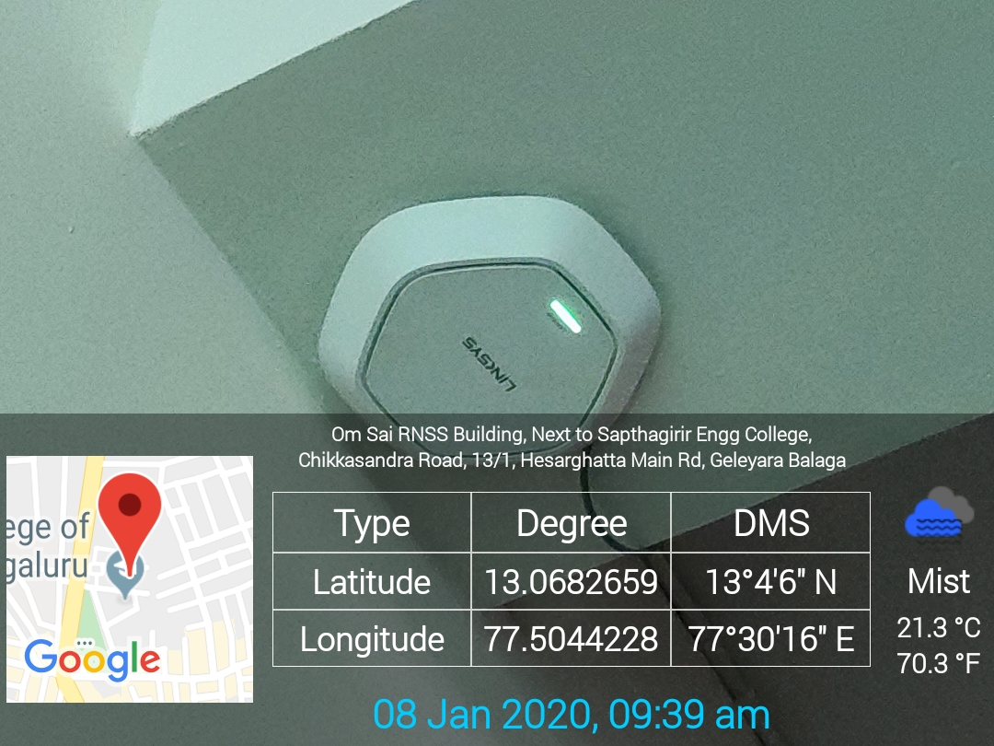
Academic Block - 3rd Floor Corridor WIFI (5)

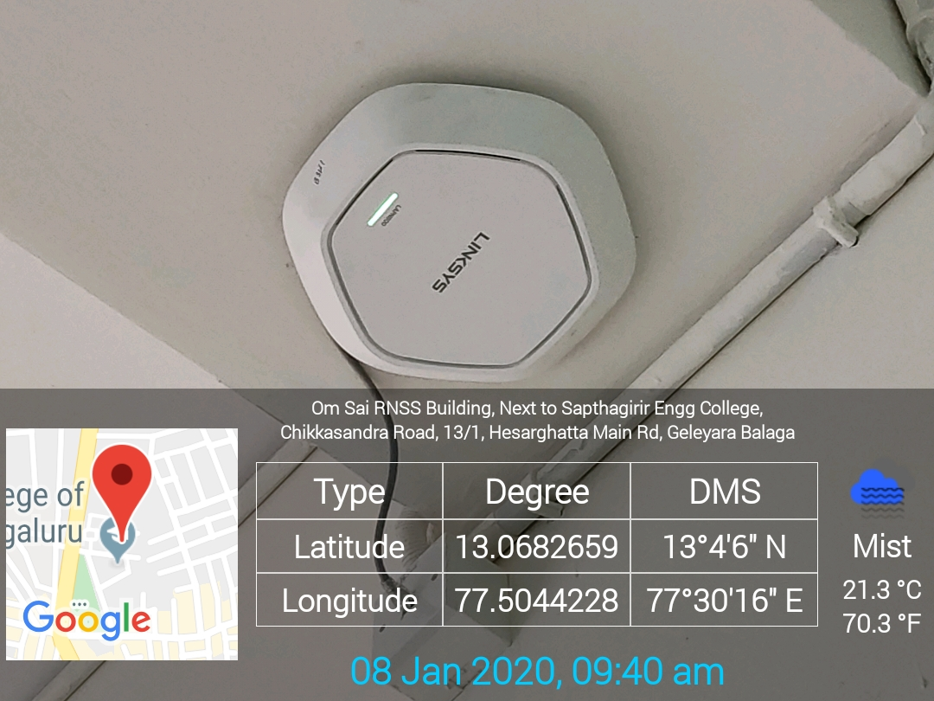
Academic Block - 3rd Floor Corridor WIFI (6)

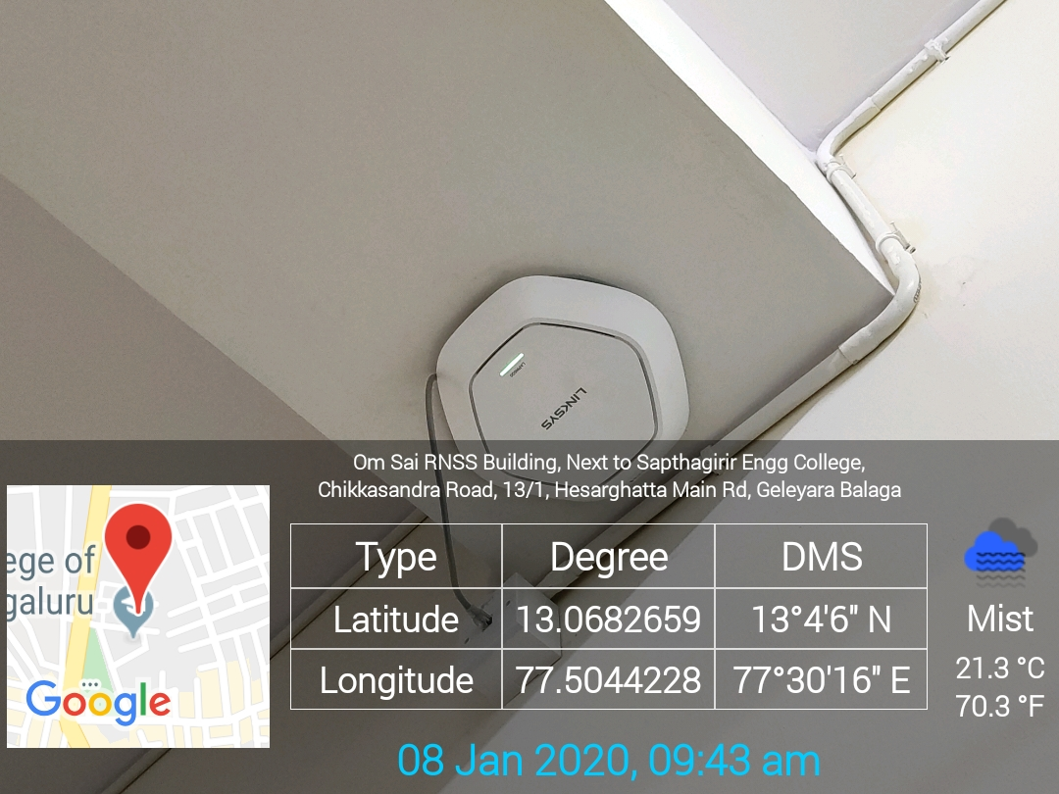
Academic Block - 2nd Floor Corridor WIFI (7)

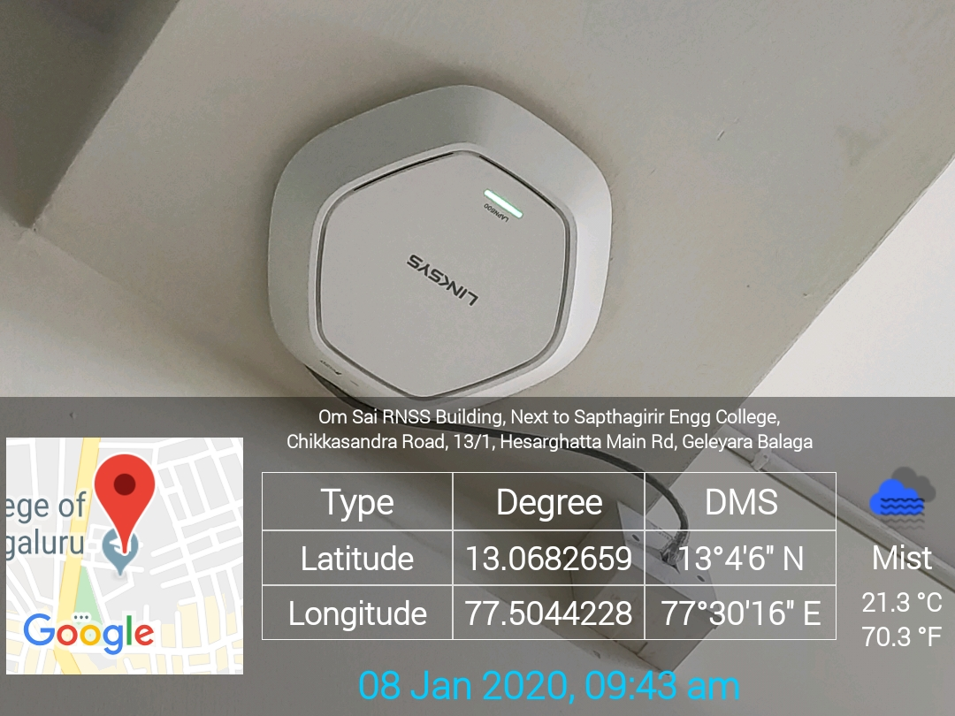
Academic Block - 2nd Floor Corridor WIFI (8)
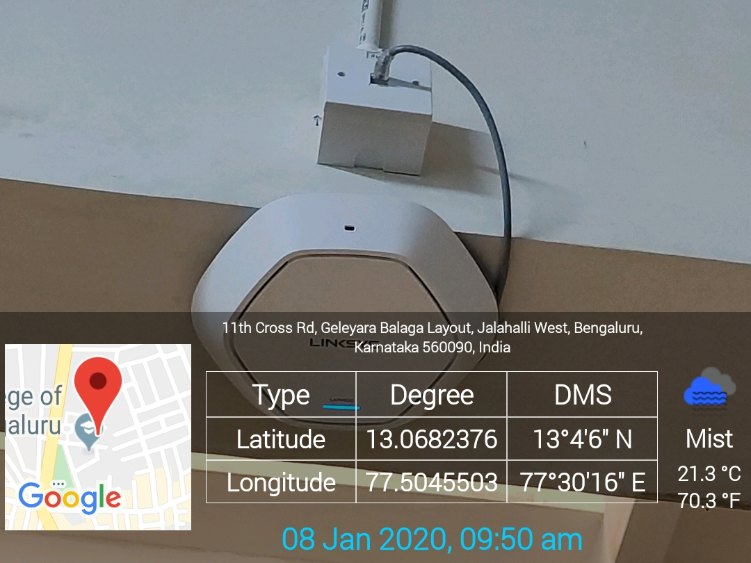
Academic Block - ECE Department – 2nd Floor Corridor WIFI (9)

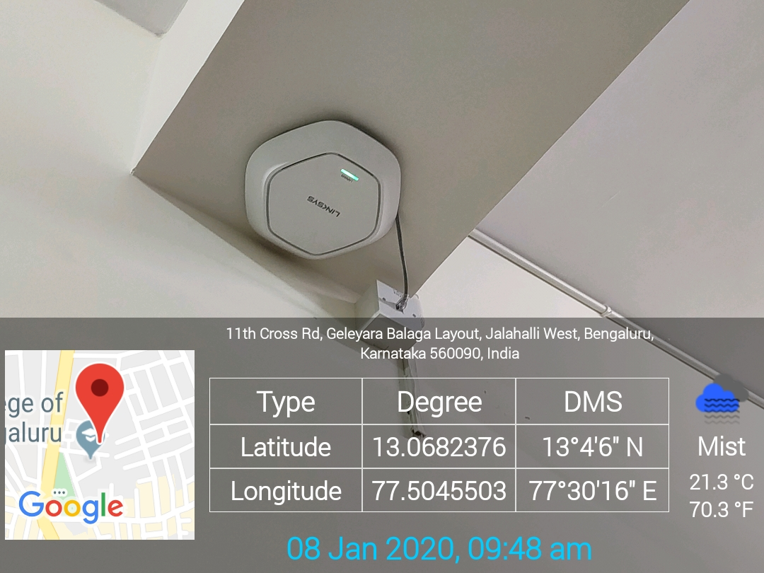
Academic Block - 1st Floor Corridor WIFI (10)

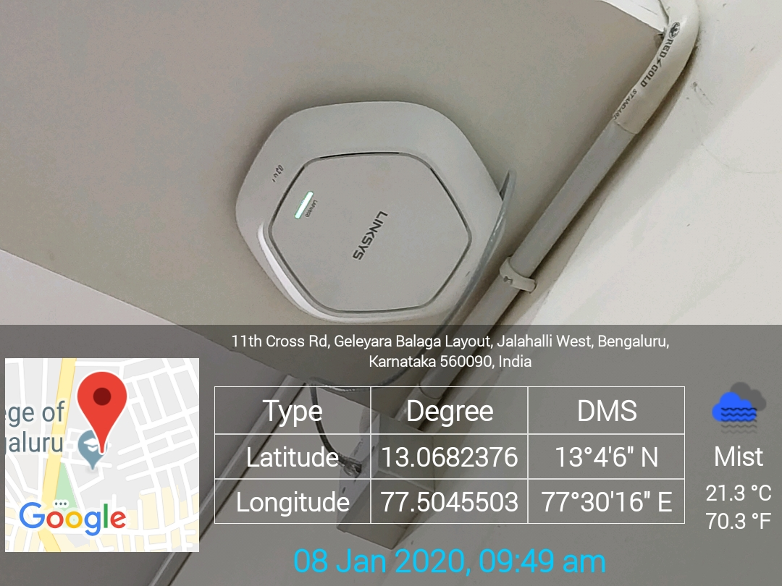
Academic Block - 1st Floor Corridor WIFI (11)

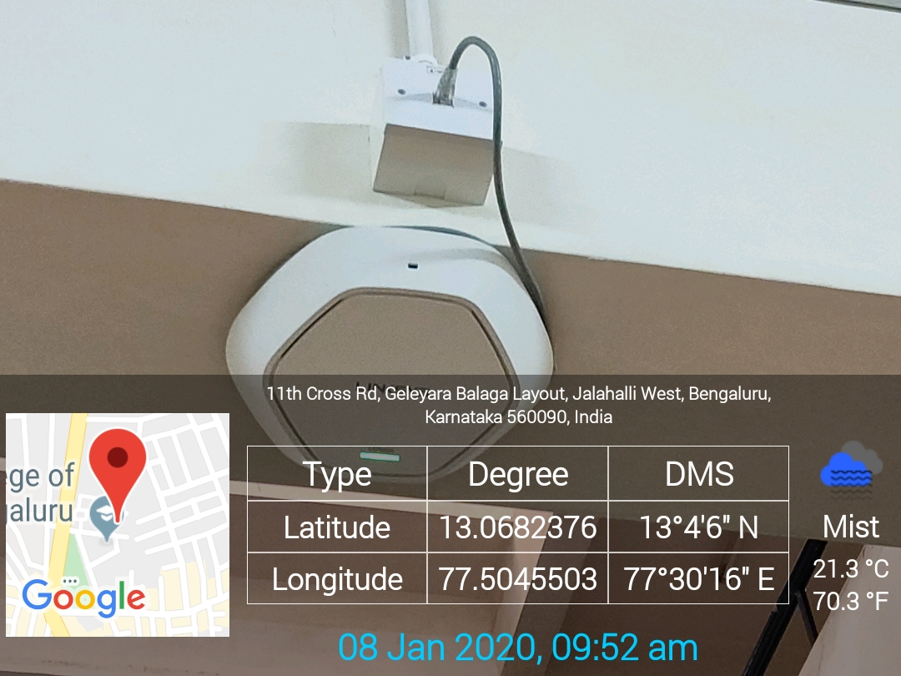
Academic Block - CSE Department – 1st Floor WIFI (12)

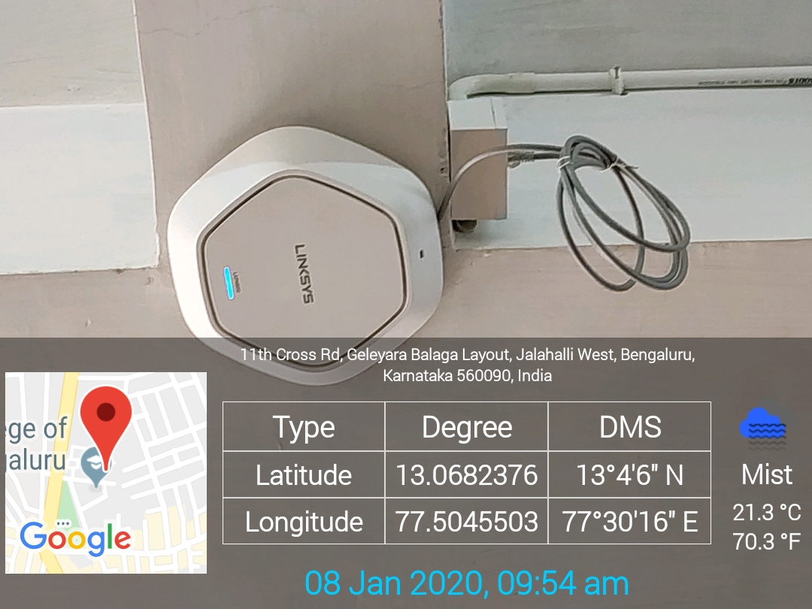
Academic Block - ISE Staff Room – Ground Floor WIFI (13)

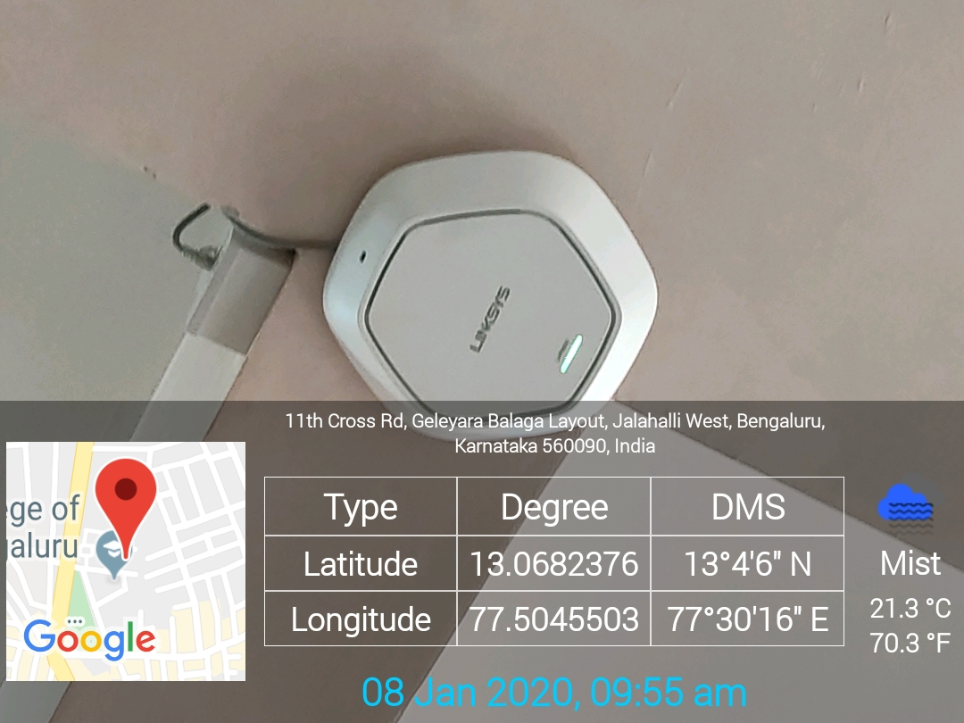
Academic Block - Mechanical Department Staff Room – Ground Floor WIFI (14)

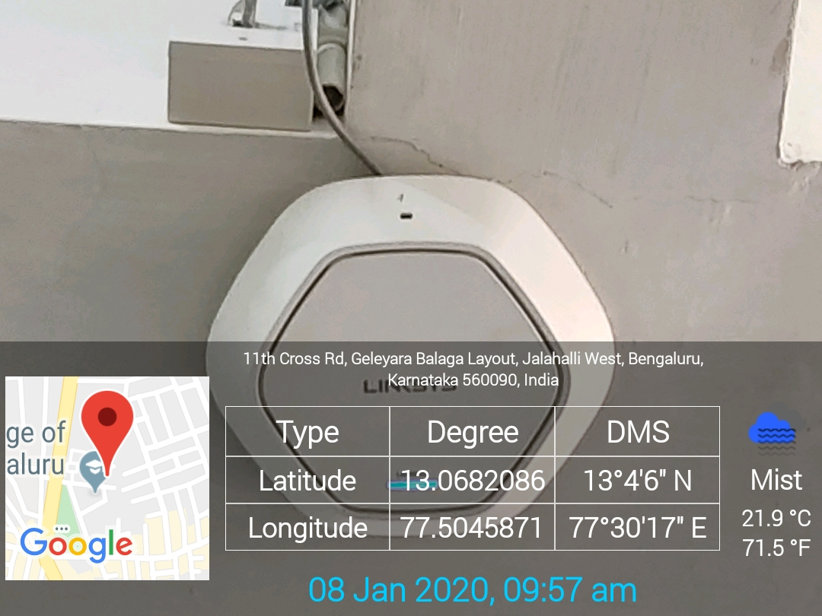
Academic Block - Staff Room 005 WIFI (15)

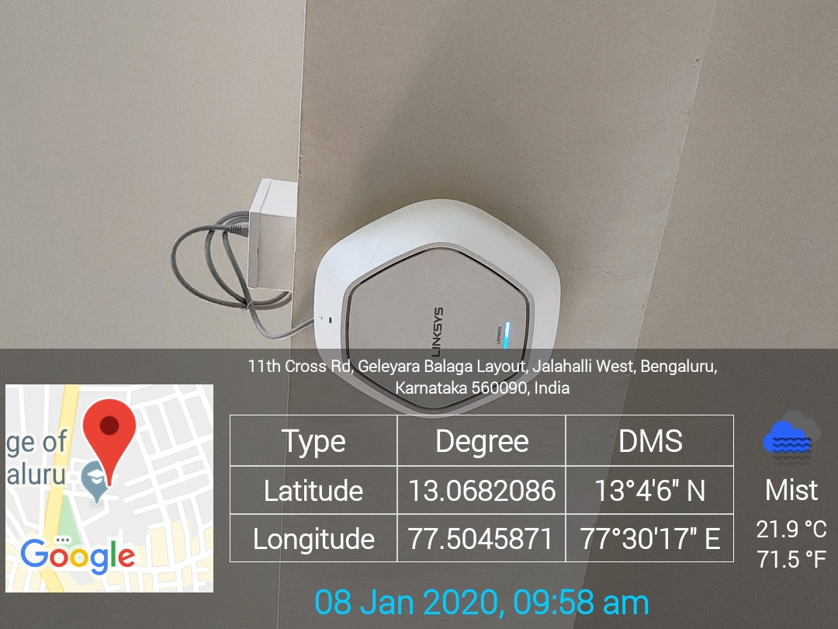
Academic Block - Mechanical Department Staff Room 004 WIFI (16)

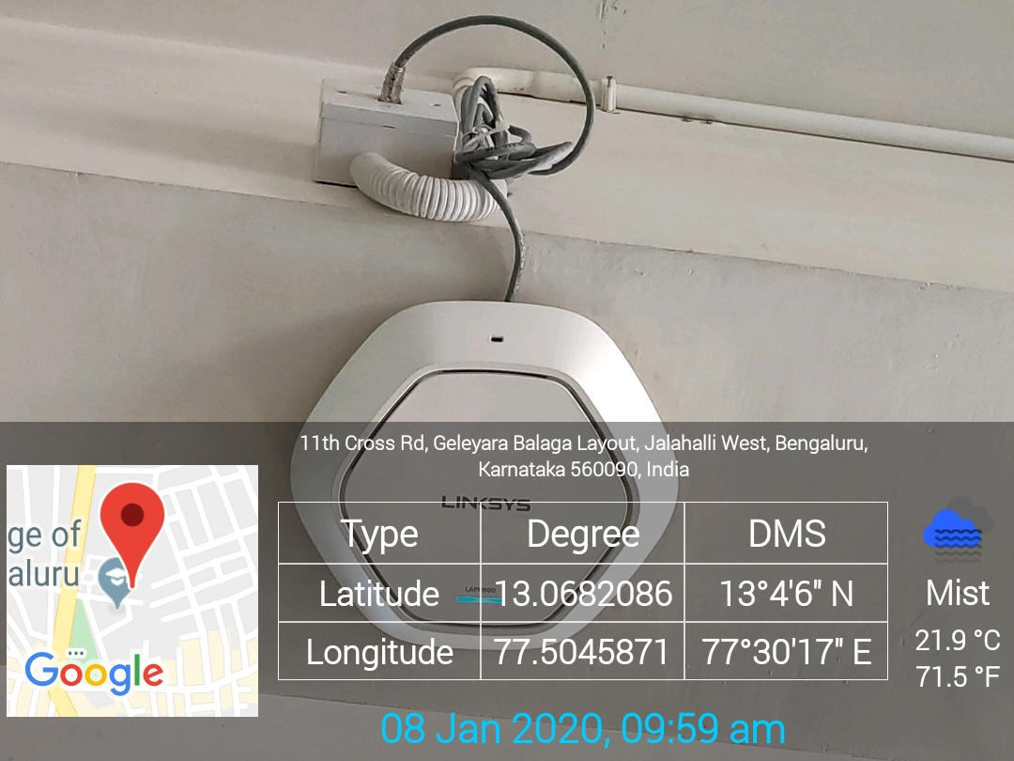
Academic Block - ECE Department Staff Room WIFI (17)
Academic Block - EEE Department Staff Room 001 WIFI (18)
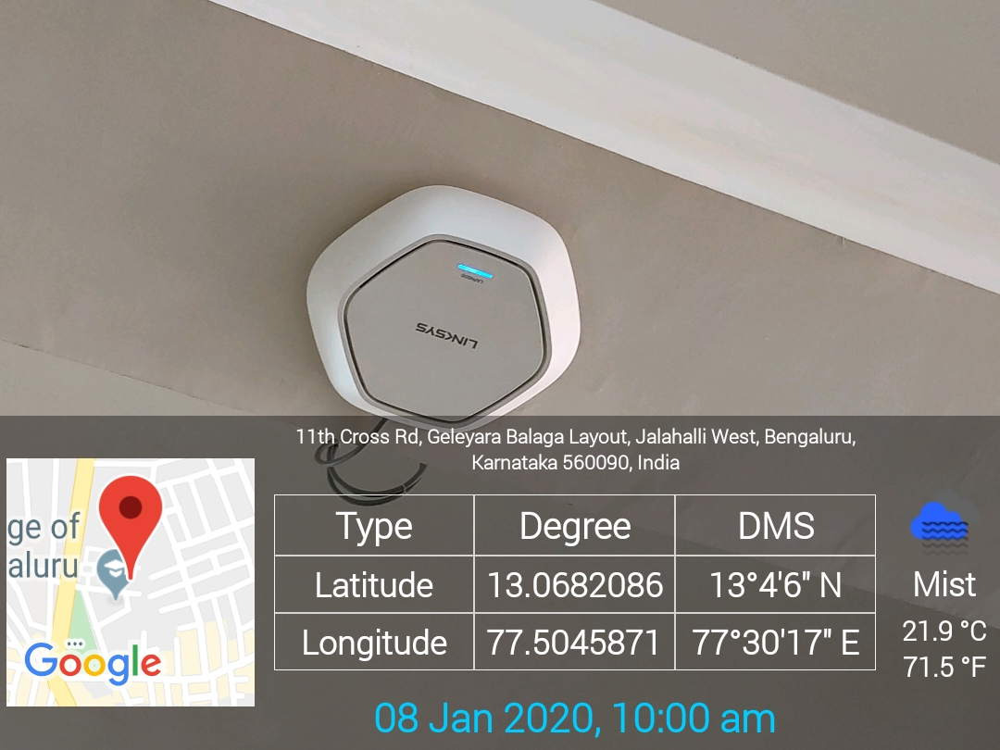

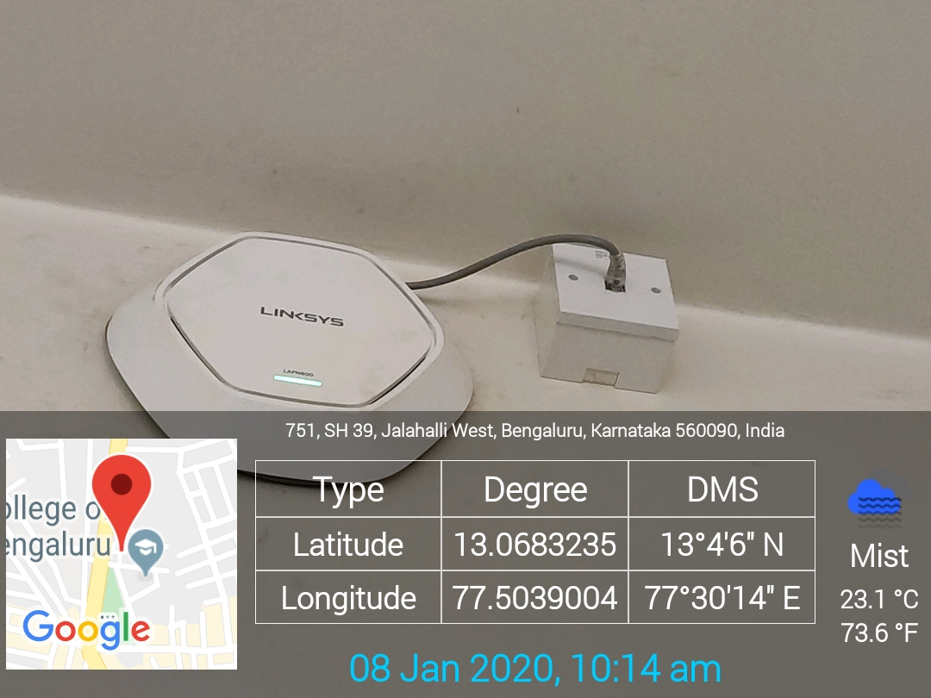
Chairman Cabin WIFI (19)

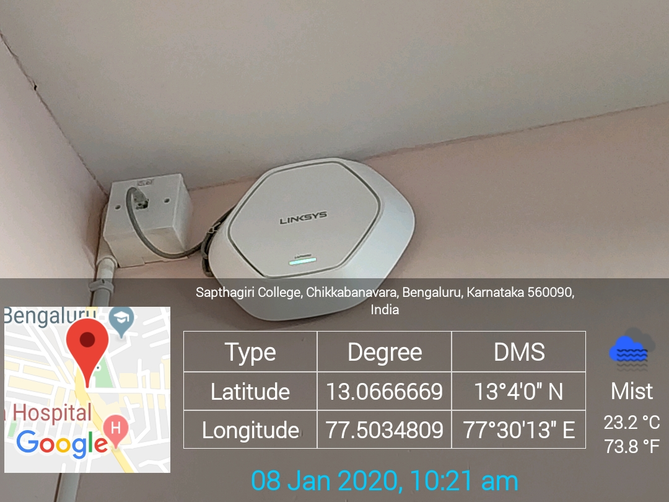
Sir M V Block - Ground Floor WIFI (20)

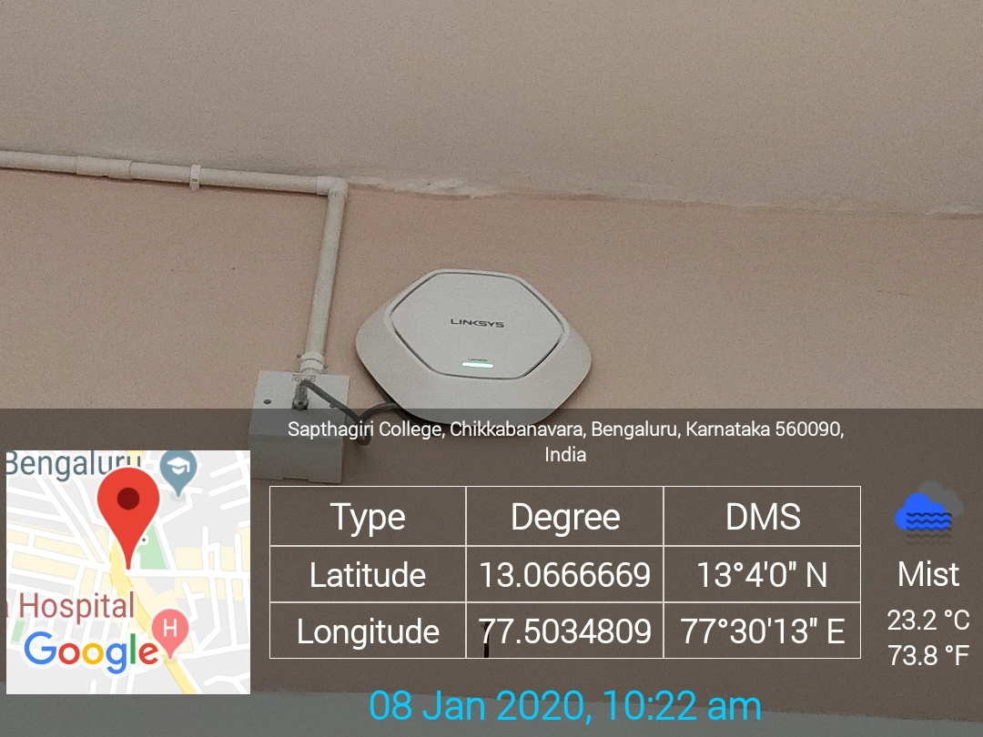
Sir M V Block - Ground Floor WIFI (21)

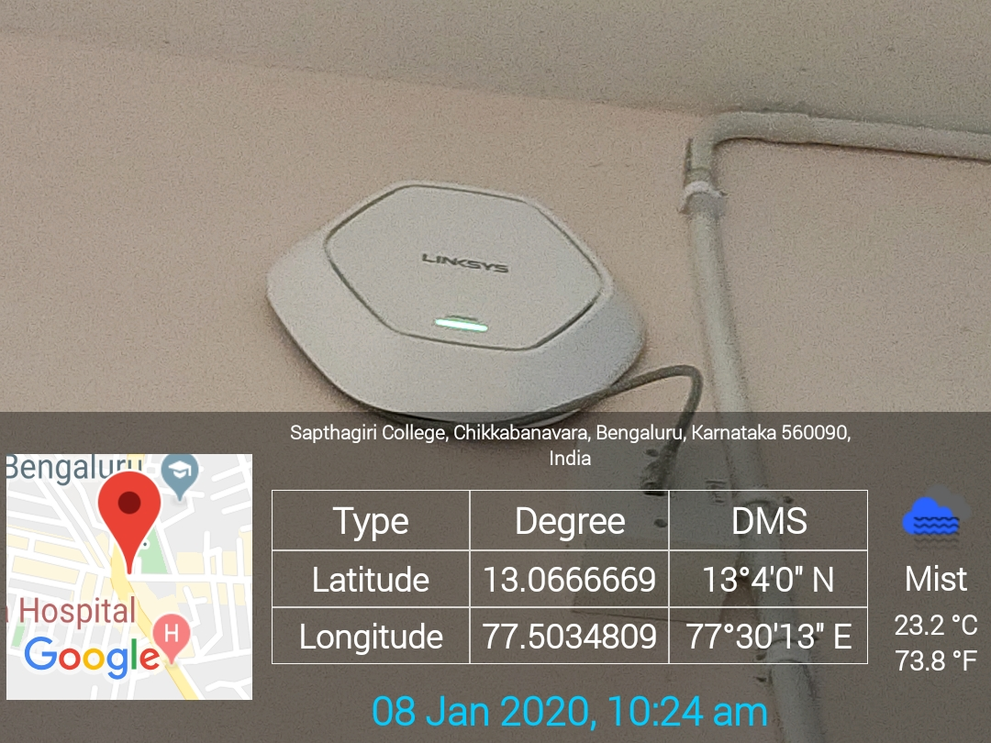
Sir M V Block - 6th Floor WIFI (22)

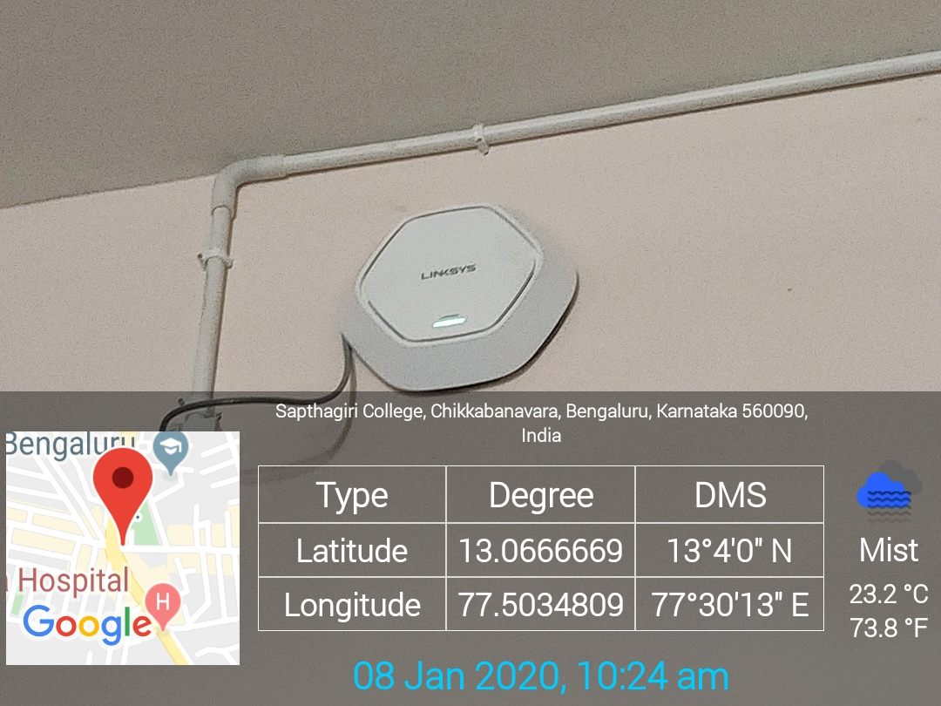
Sir M V Block - 6th Floor WIFI (23)

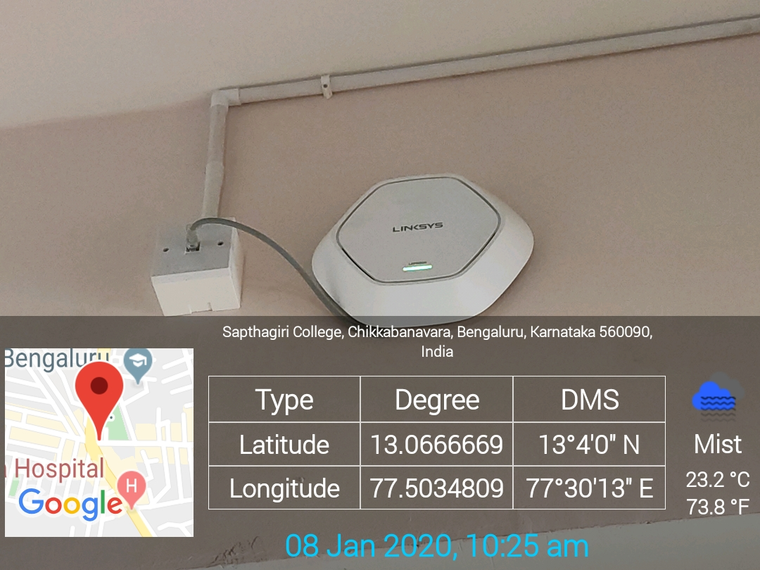
Sir M V Block - 5th Floor WIFI (24)

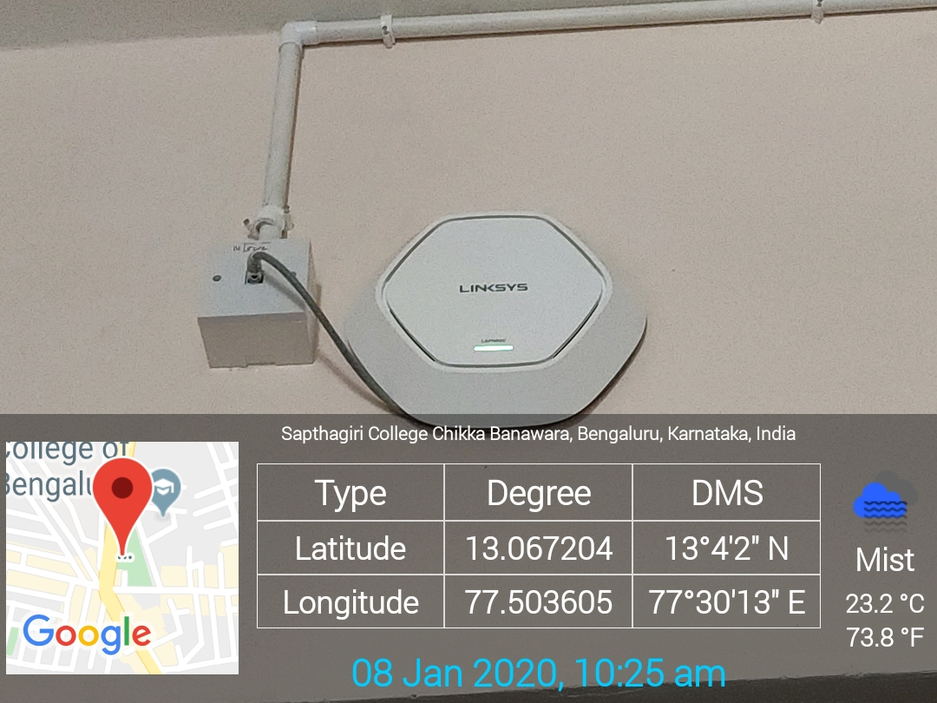
Sir M V Block - 5th Floor WIFI (25)

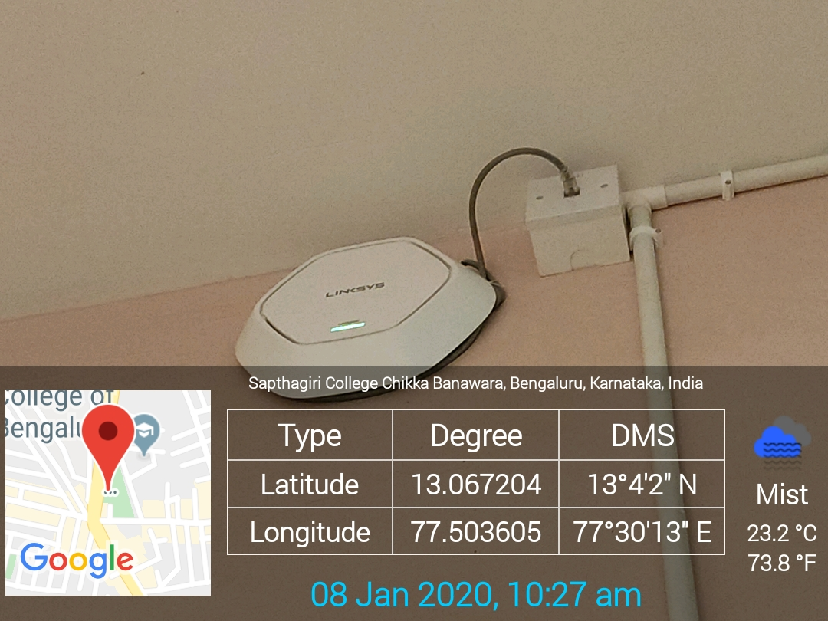
Sir M V Block - 4th Floor WIFI (26)

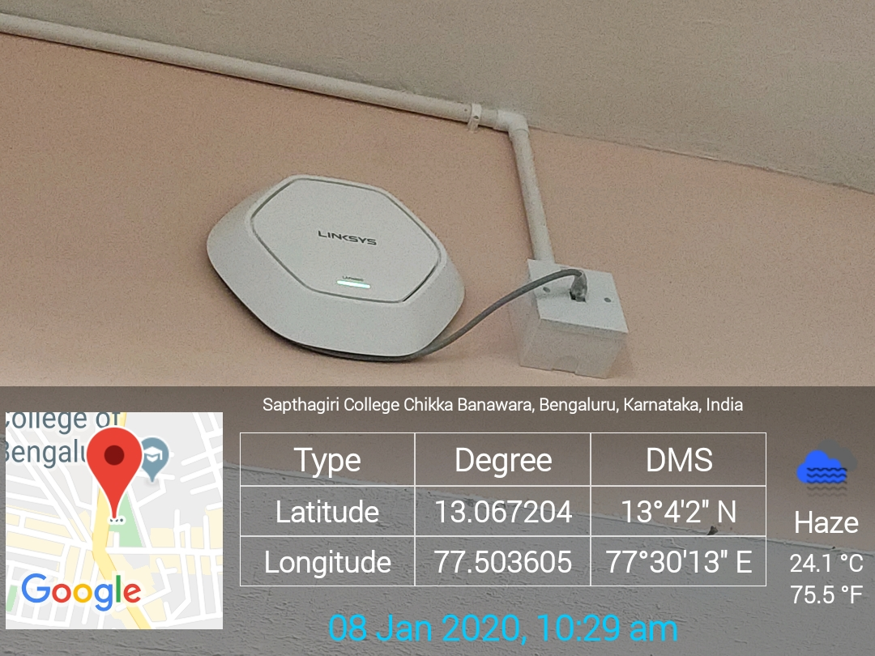
Sir M V Block - 3rd Floor Library WIFI (27)

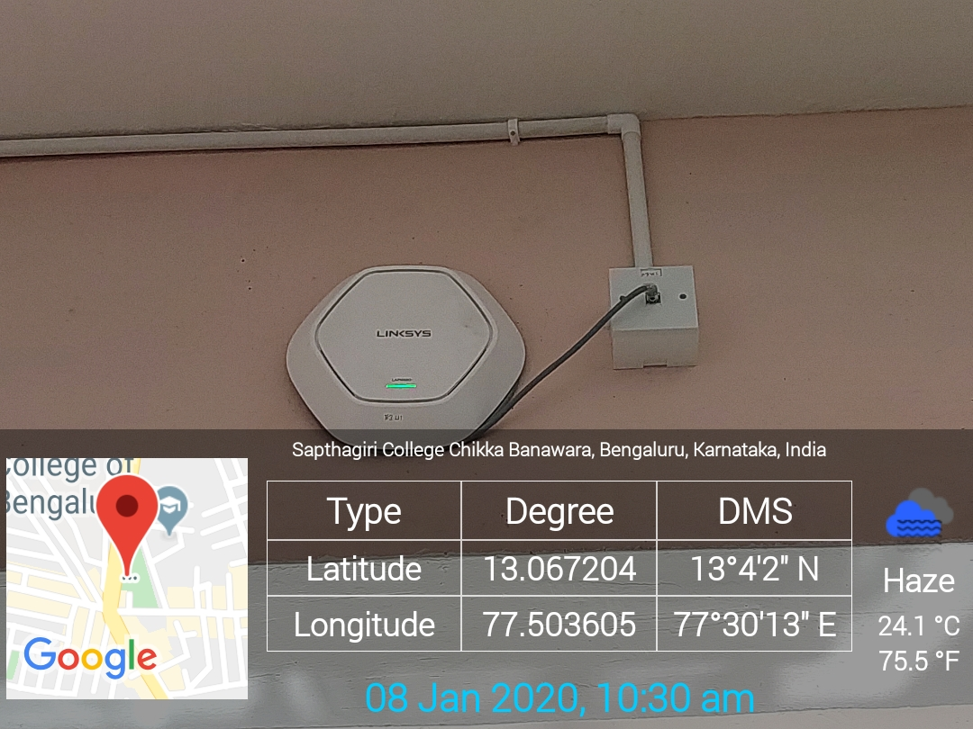
Sir M V Block - 3rd Floor Library WIFI (28)

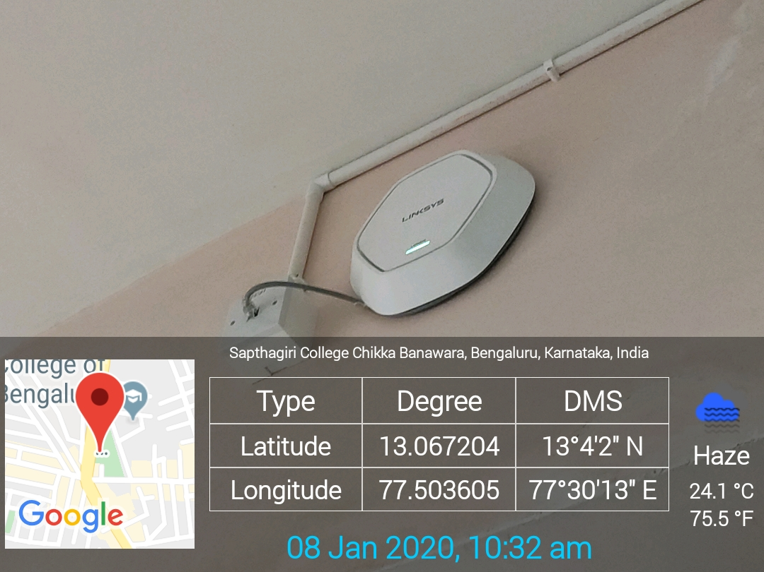
Sir M V Block - 2nd Floor Library WIFI (29)

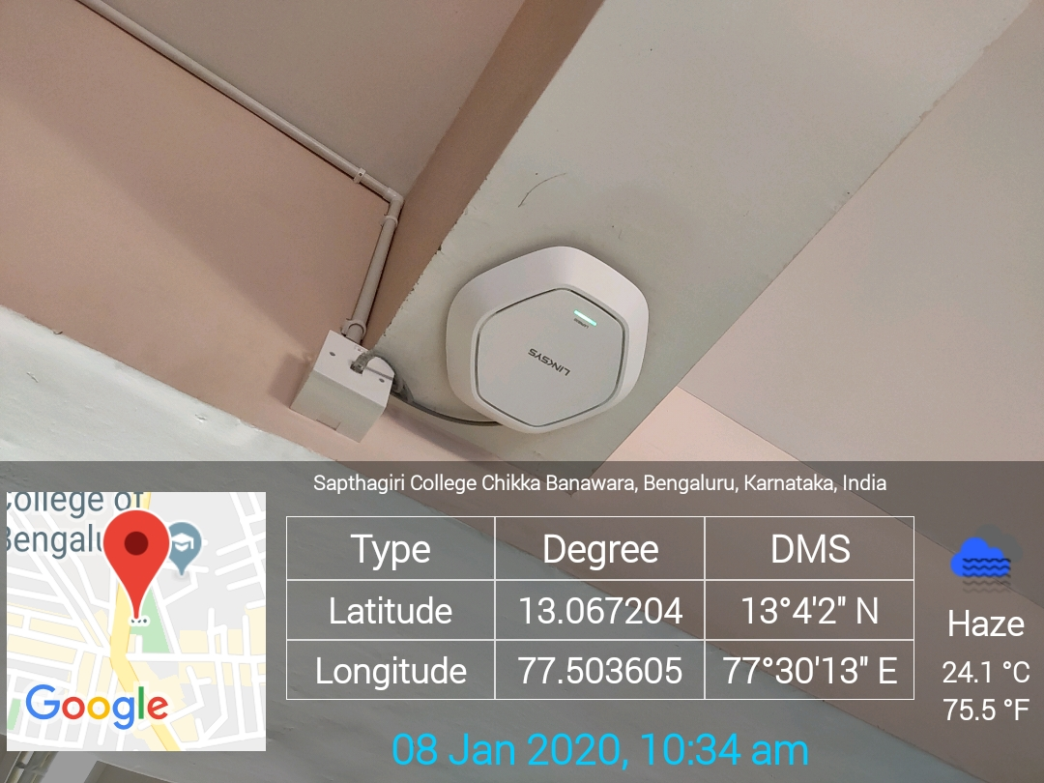
Sir M V Block - 2nd Floor Library WIFI (30)

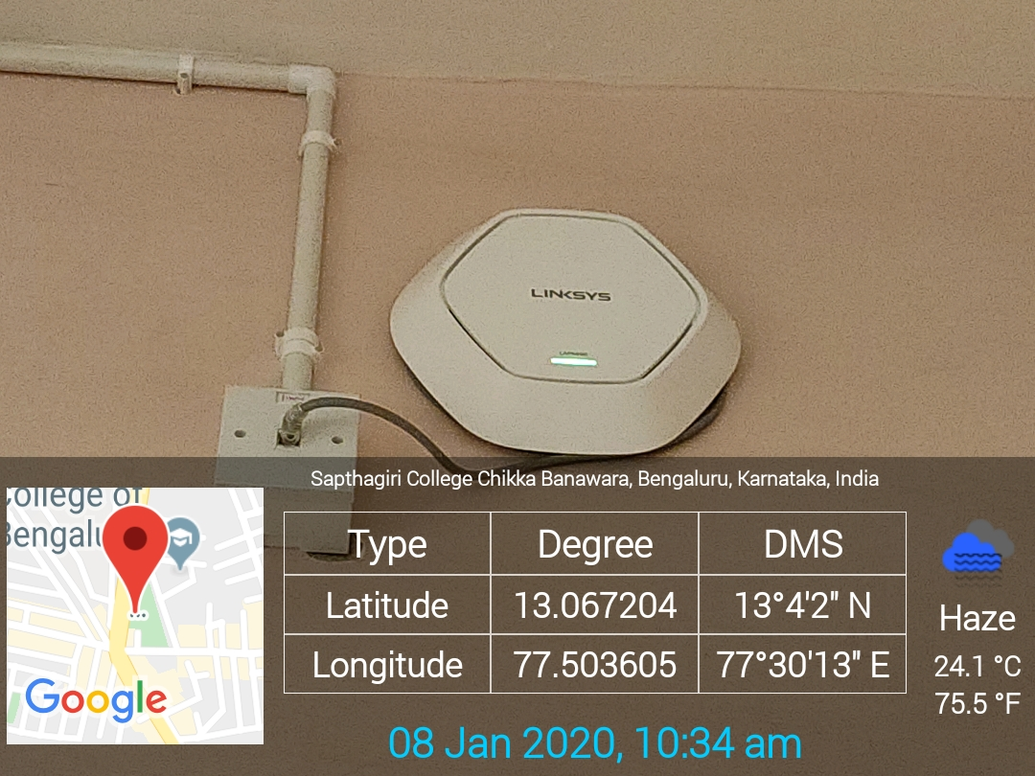
Sir M V Block - 1st Floor WIFI (31)

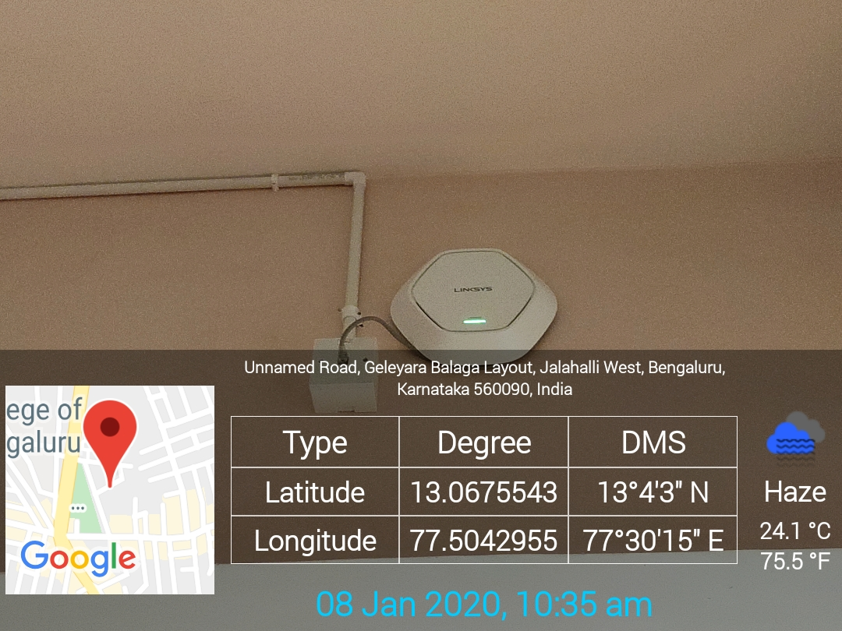
Sir M V Block - 1st Floor WIFI (32)

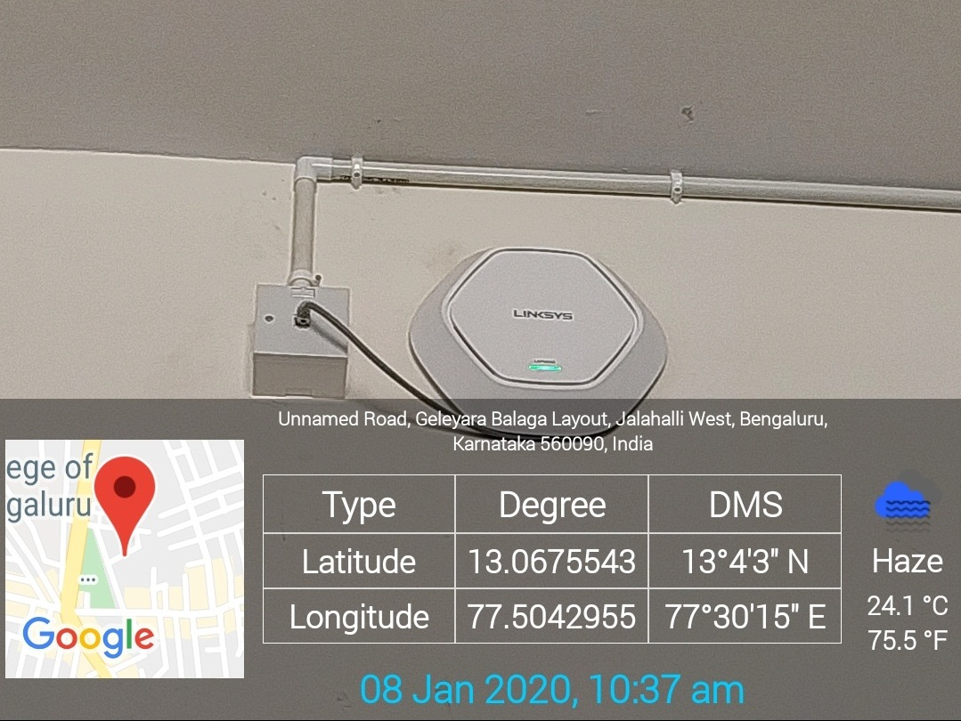
Faraday Block WIFI (33)

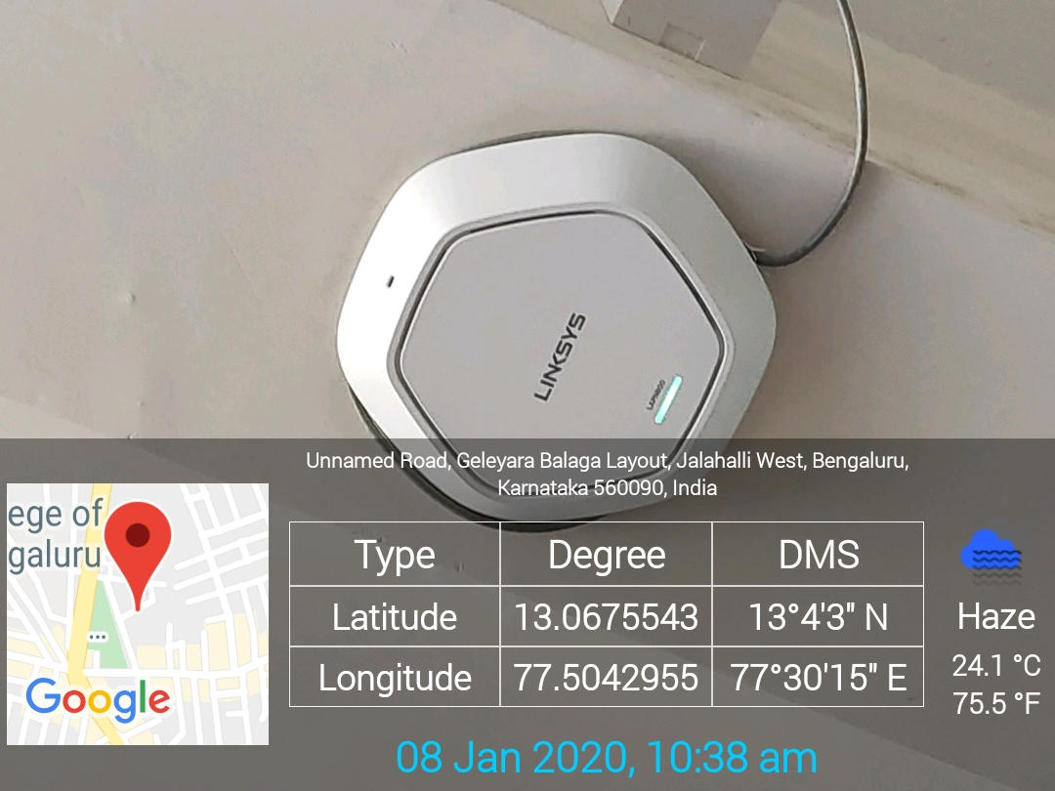
Placement Department WIFI (34)
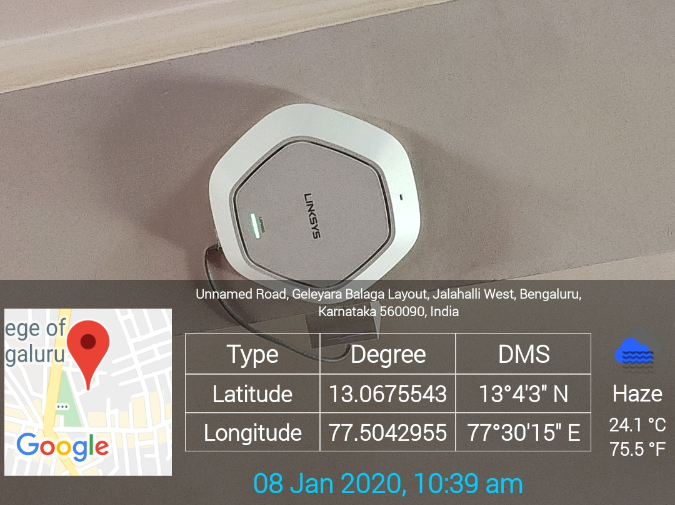
Seminar Hall WIFI (35)

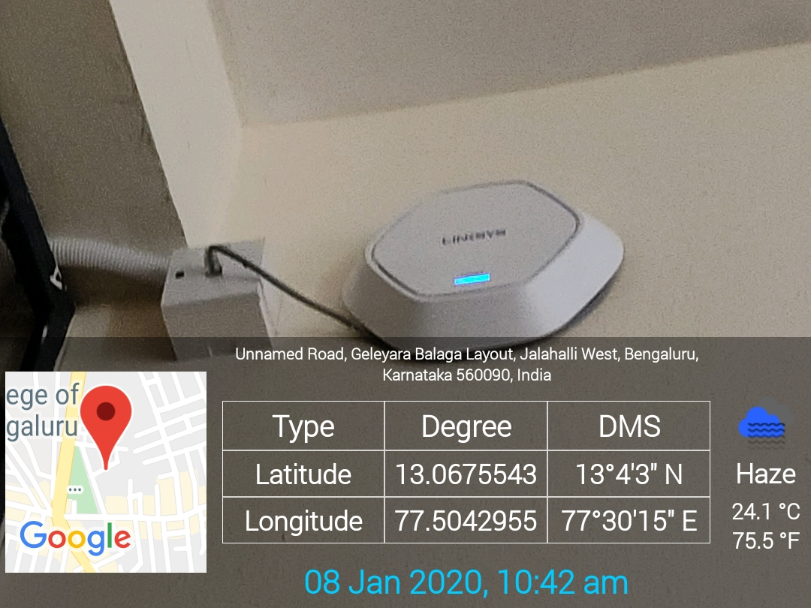
Mechanical Department Basement WIFI (36)
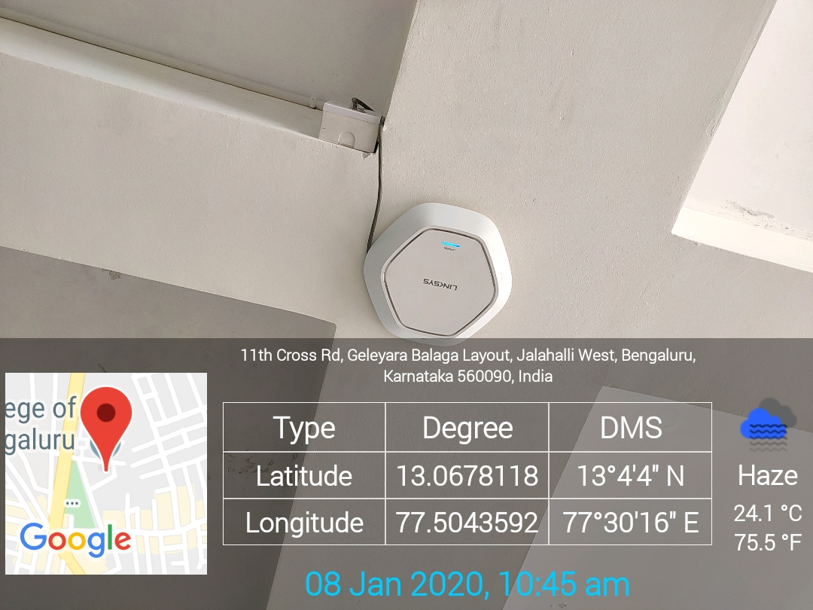
Biotechnology Department WIFI (37)

