    - Additional Information for Curriculum planning and Implementation

INDEX

Sl. No. | Name of the Document | Page No.
 | Subject Option | 2
 | Subject Allocation | 3
 | Curriculum plan & delivery | 4
 | Lesson plan diary | 5
 | Course Attendance Register | 6
 | Course File | 8
 | Academic Audit | 9
 | Content beyond Syllabus | 10

Subject Option

Each and every faculty has an option to select and fill the subject which they are interested for every semester in the subject preference form. Head of the Department use this form for allocating the subject to each faculty based on their choice of preference.

Subject Allotment

Sapthagiri College of Engineering follows systematic methods for allotment of subjects to faculty. HOD conducts the meeting and allots the subjects based on faculty area of specialization and their choice of preference .The sample copy of the faculty subject allotment form is given below.

Curriculum plan & delivery

Sl.No. | Date | Topic/  Chapter/Module | Curriculum | Deployment Strategy and Tool | PO, PSO and CO | Attainments | Attainment Verification
1.
2
3

Lecture plan dairy

Each faculty prepare a lesson plan and Diary for the allotted subjects in the following format

Course Attendance Register

Course Attendance registers are maintained in both theory and lab classes. It consists of following information

- Daily attendance

- Internal Assessment marks

- Final IA marks

- SEE Marks & Total marks

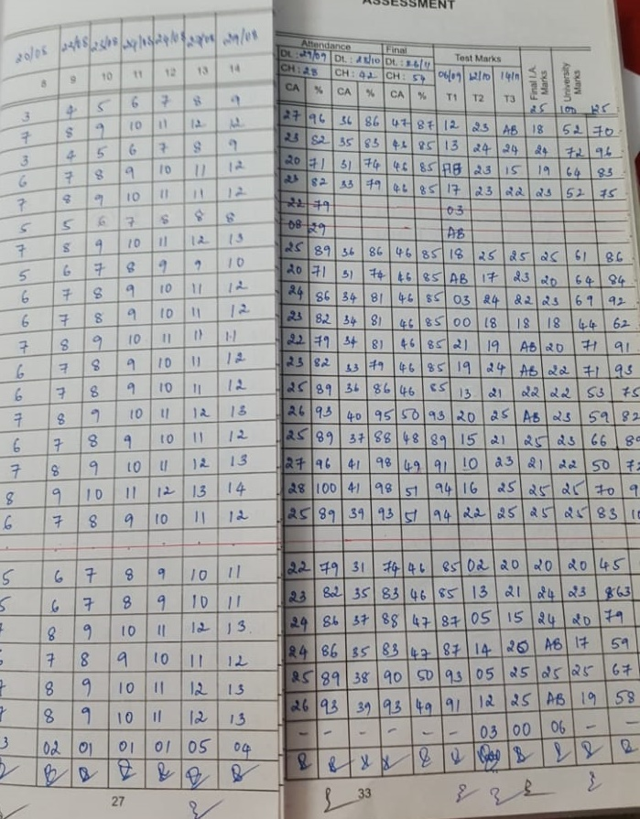

Course File

Every faculty member prepares course file for the theory subjects after the completion of subject allotment. Course file is arranged with the following documents in order.

COURSE FILE
List of documents

Academic Audit

Academic Audit is conducted once a year at the middle of ODD semester of every Academic year .Every faculty member maintains course files for the theory as well as for Laboratory subjects. IQAC convenes the academic audit committee. The auditors audit the files and give feedback to faculty. If any non compliance is found, the faculty rectifies and closes them.
The sample copy of Academic Audit form is shown
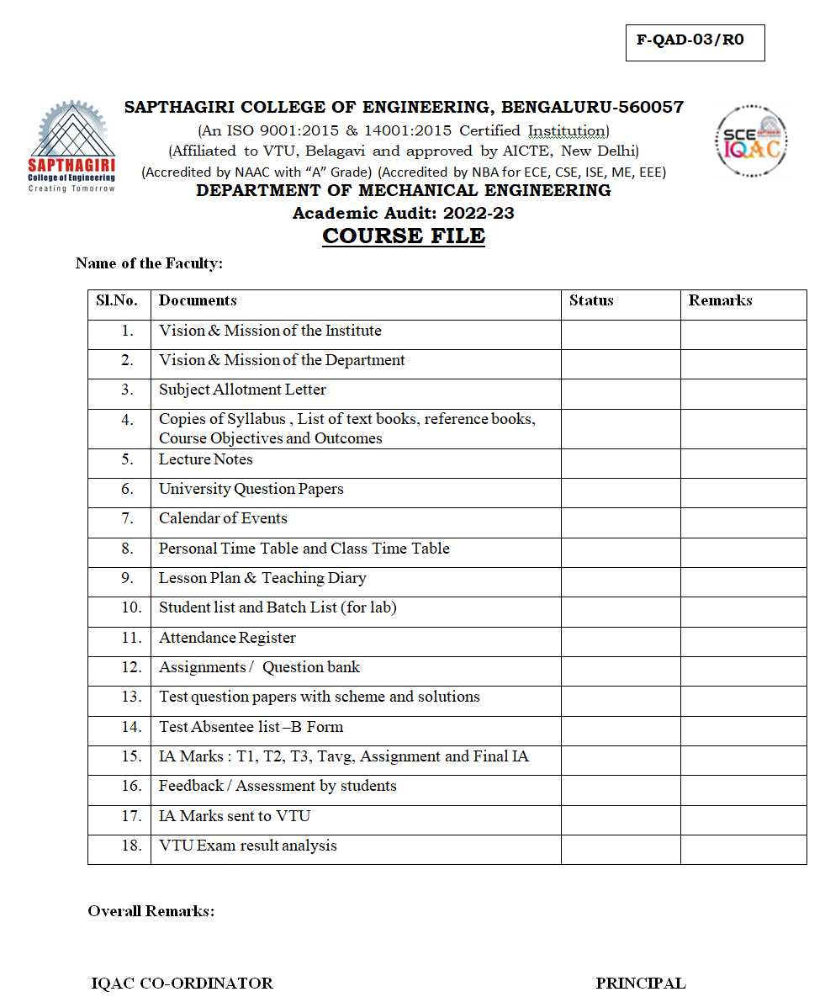

Content beyond Syllabus

Content beyond Syllabus is identified through taking feedbacks from the stake holders and delivered through taking extra classes, guest lectures, mini Projects, industrial visits, skill development trainings, certification courses & workshops.

