Alumni Meet - 02/08/2014
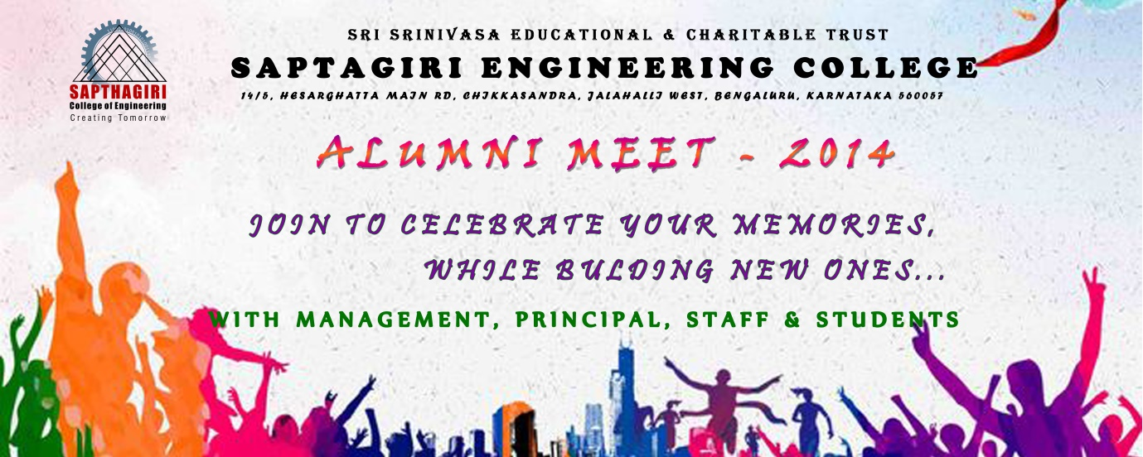

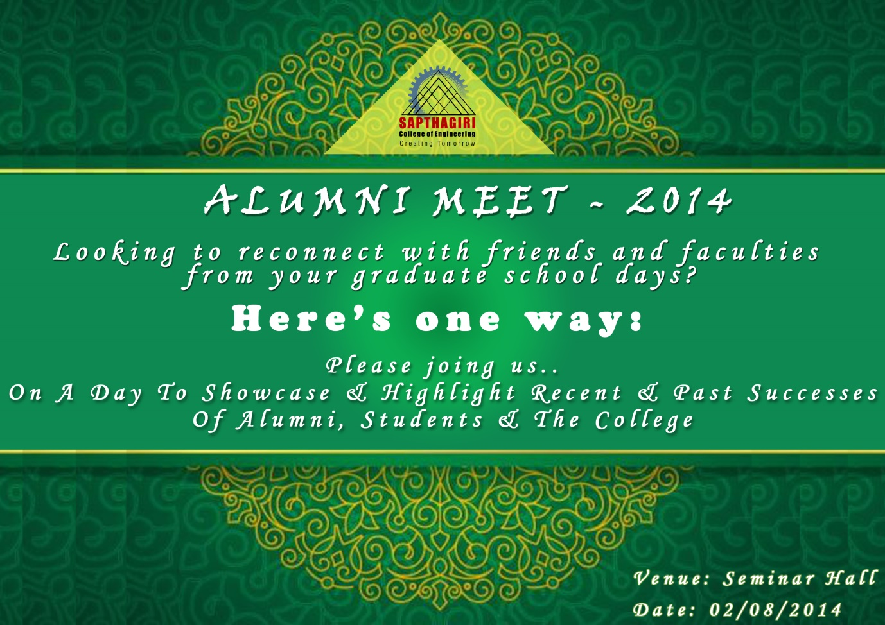

Meeting held for deciding future course of action to strengthen Alumni
Record of Discussion
Venue: Admin Block
Date: 02 / 08 / 2014

Members of the meeting:

From College
- Mr. Puttamadappa, Principal, SCE.
- Mr. Ananda S. HOD, BT Dept.
- Mr. Manjunath S.H, HOD, ME Dept.
- Mr. Ravi, HOD , EEE Dept.
- Mr. Prashant C.M, HOD, CSE Dept.
- Mrs. Sandhya Rani, HOD, ECE Dept.
- Mrs. Prerana Chaitra, HOD, ISE Dept.
- Mrs. Pushpa B.V, HOD, Mathematics Dept.
- Mr. Krishna, HOD, Chemistry Dept.
- Mr. Jagadeesh Gowda, HOD, Physics Dept.
From Alumni
- Mr. Ankur Kacker, Treasurer, Alumni Association.
- Mr. Abhishek G
and the rest.

The members agreed right in the beginning that the college’s overall improvement is directly related to the quality of the Alumni members. Hence, this meeting took a comprehensive approach to address the concerning issues. Special emphasis was laid on awarding autonomy to the Alumni association, by the Alumni members. A need was cited to establish an industrial interface, improve the standard of faculty and get better companies to campus for placements.

The following are the recommendations:
It was indeed a great blissful and awesome day to coin out the best things for the betterment of the Sapthagiri Alumni. Keeping the agenda and Vision in mind following are the minutes discussed in meeting held on Saturday.
Great action implemented till now review and new ideas coined up :
Scheduling a meet up for the core team members with the college management once in 2 months.
Opening an Sapthagiri Alumni Bank account by Suma hiremath , Ankur karcher
Conducting a Technical workshop / talk by Avinash , Vivek , Mahalingesh and whole team in college in September 2nd week.
Associating Meghana foundation NGO with other organisation like Youthseva sangha , Think vidhya , Vidyaposhak by Sharas.
Bringing in the Student programme of IBM and Microsoft back to college
Bringing in idea of Textweb project to action by Mahalingesh Madanshetti guidance and android app development by Vivek kumar guidance along with college students.
To plug gaps in communication, the Alumni has agreed to meet the College Authorities once every month on a mutually agreed date. Alumni Coordinator is entrusted with the responsibility to communicate and organize the same. A review to ascertain closure of above said action points to be held in the successive meets.

S/d,
SCE Alumni

Photo Gallery:

