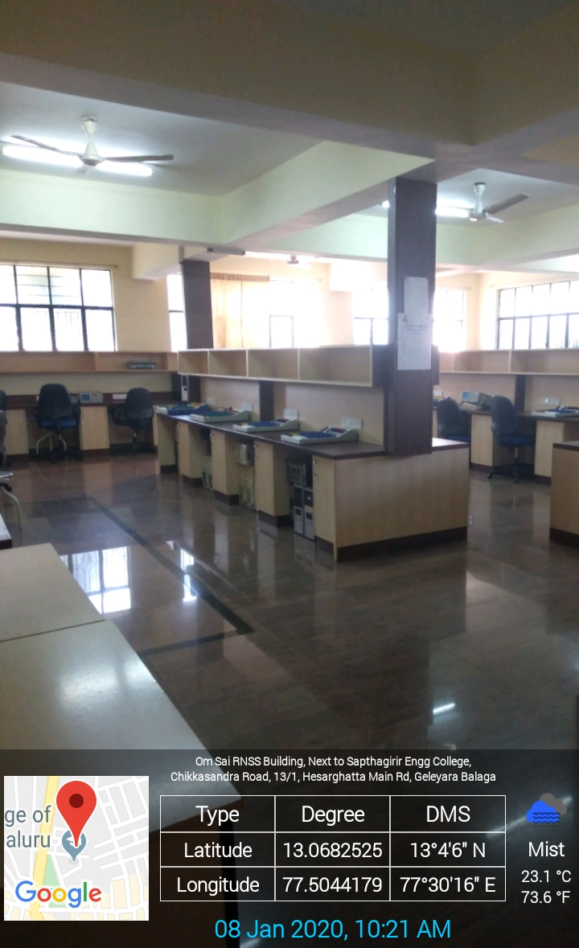
Electronics Circuit and Logic Design Lab

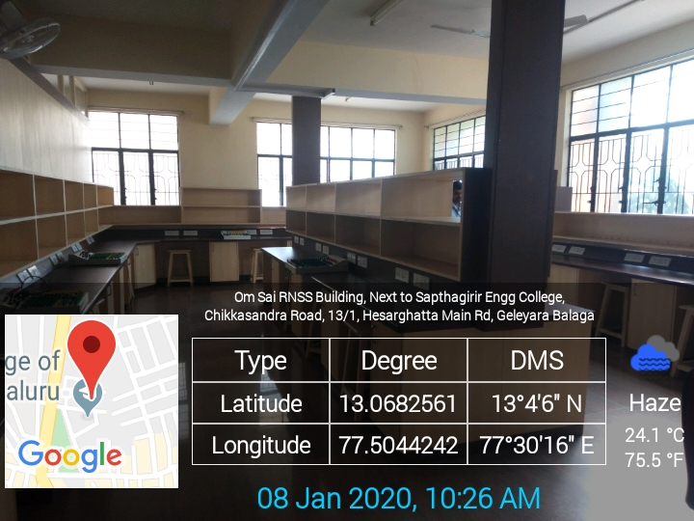
LD Lab

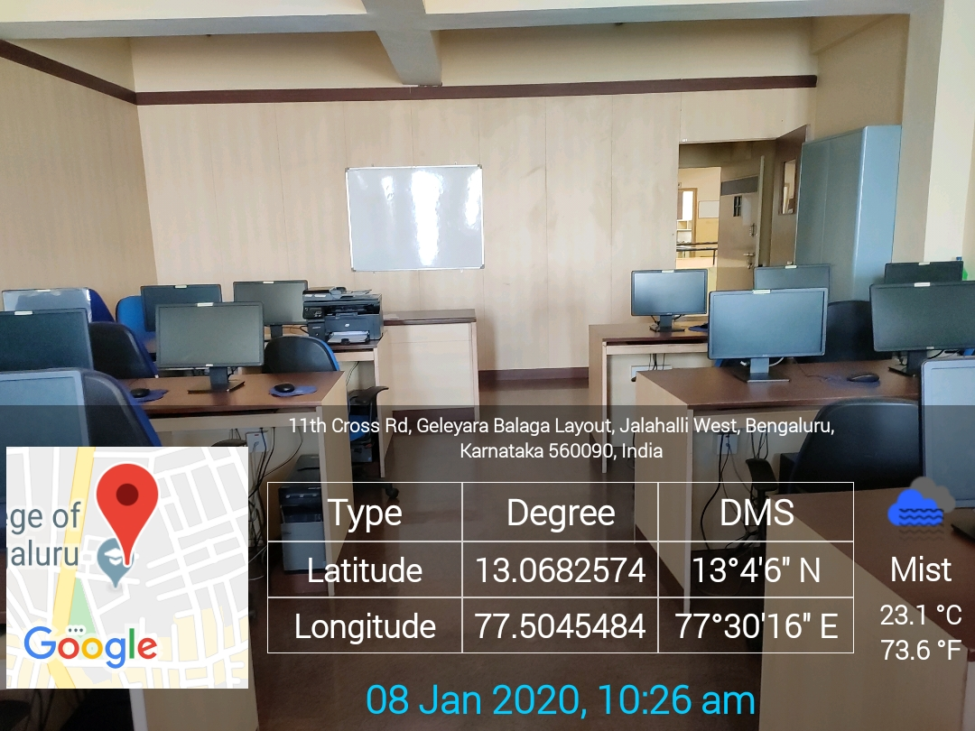
Academic Block -ECE 105 - ---------------Lab

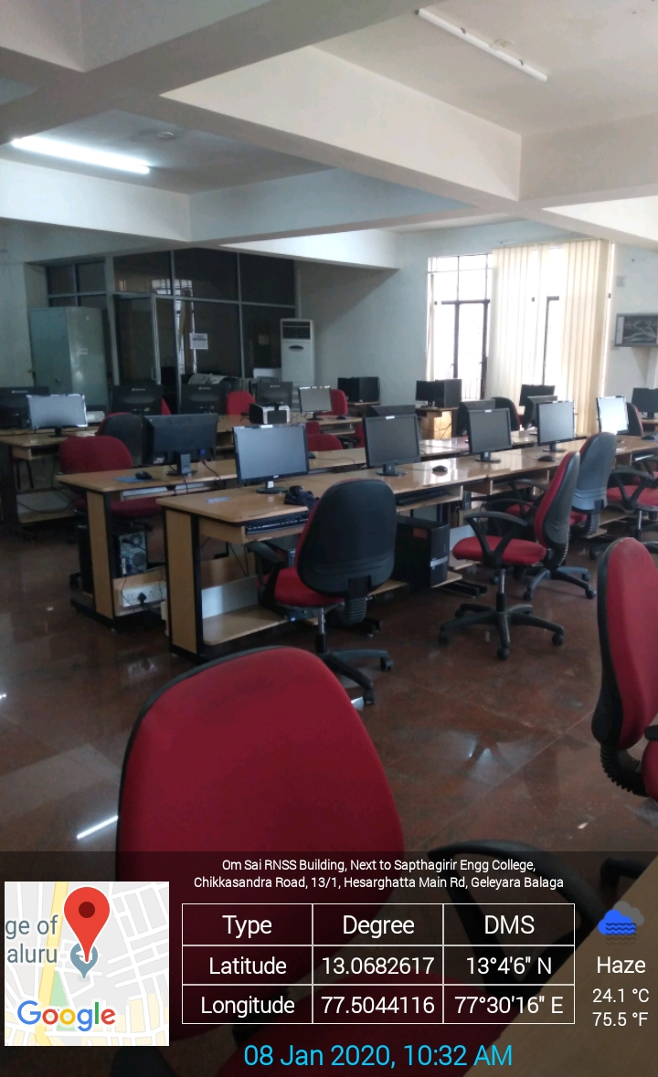
Academic Block -ECE 105 - ---------------Lab

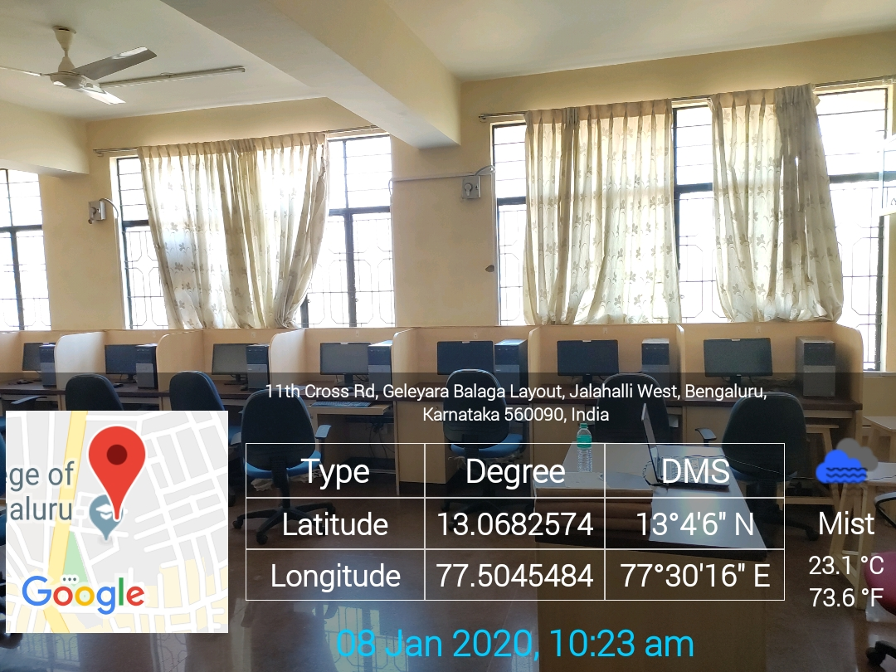
MTECH - PG Lab

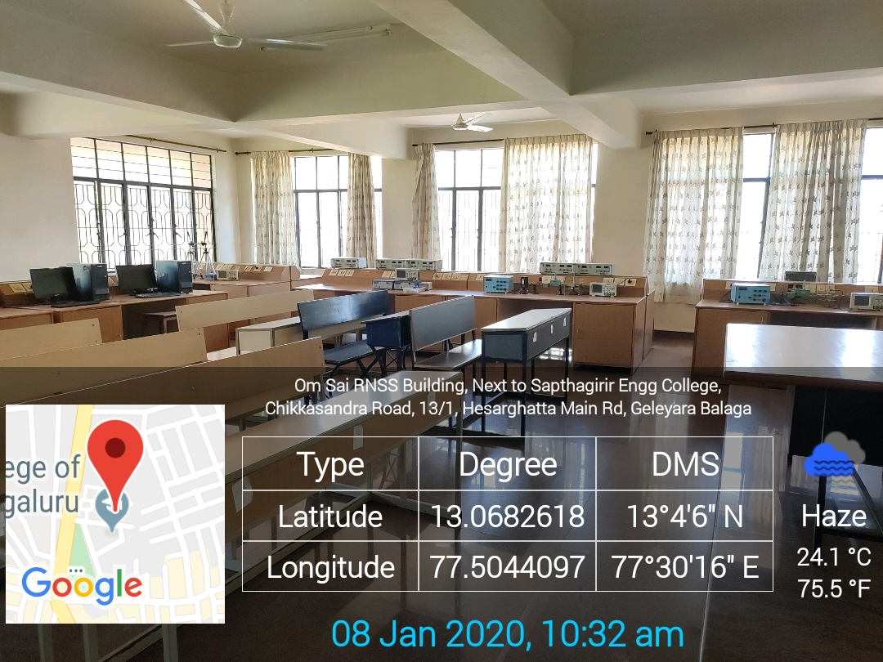
Academic Block -ECE 101 - ---------------Lab

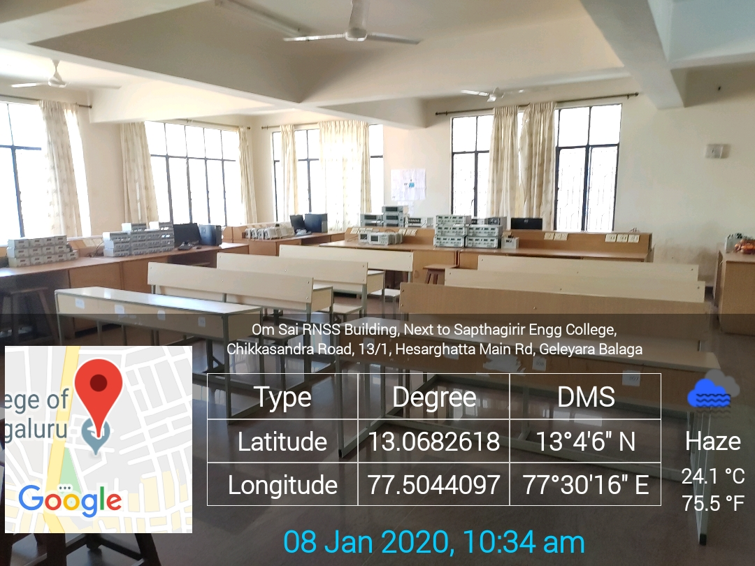
Academic Block -106 - ---------------Lab
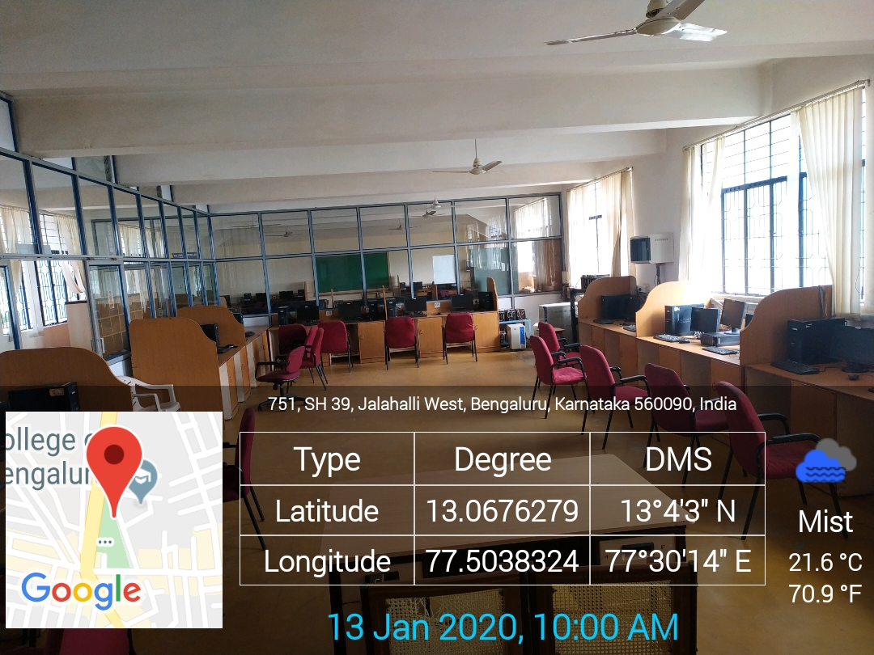
VLSI AND VHSL

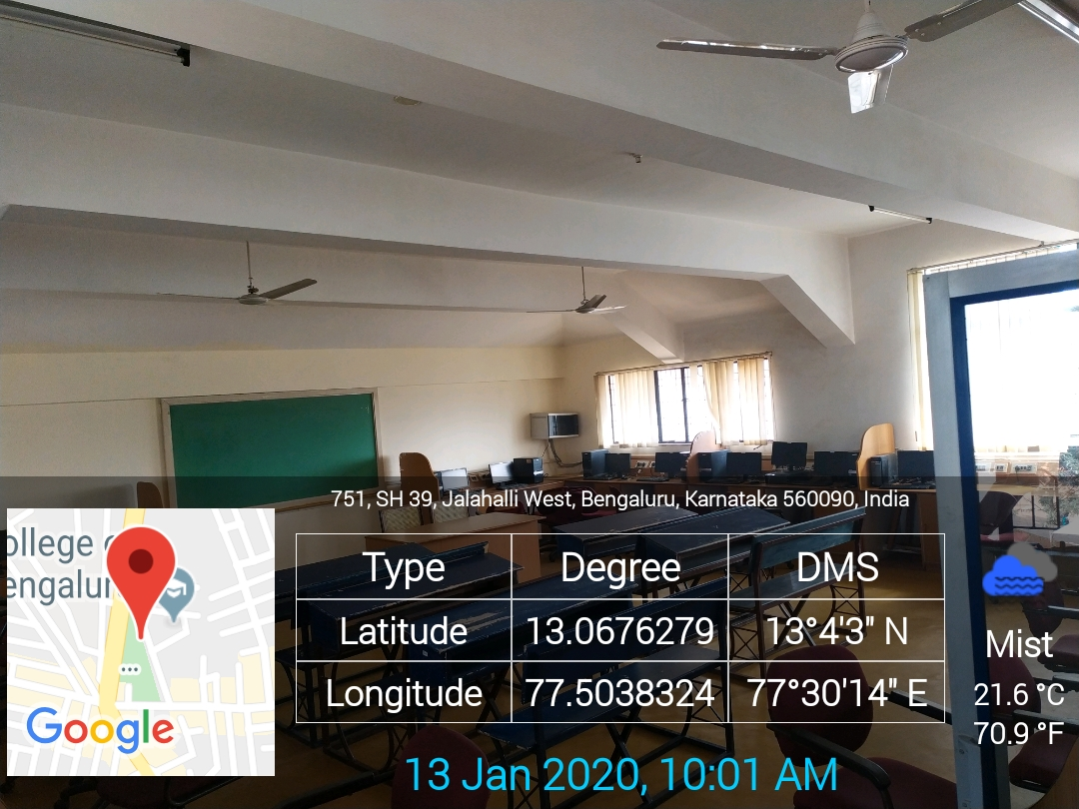
Micro-controller lab

