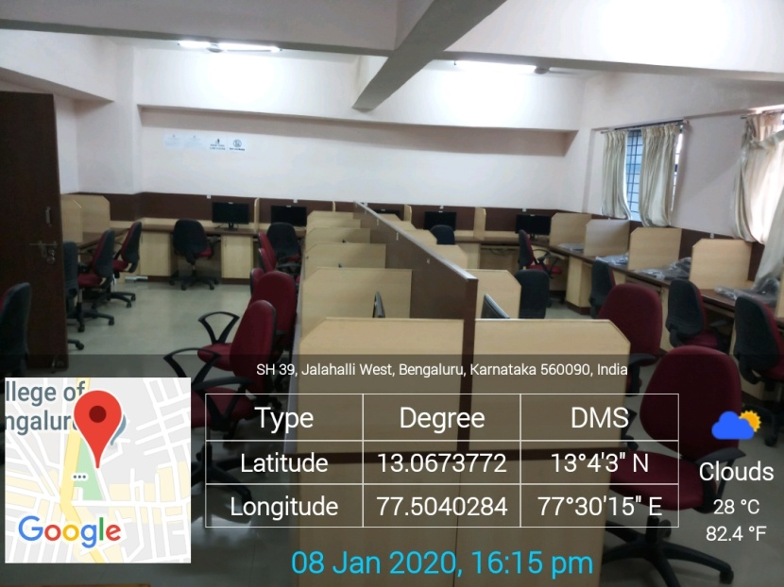
Sir M V Block-4th Floor CAD Lab

